Inspiration Lesson Plan Extension- Origami Rocket
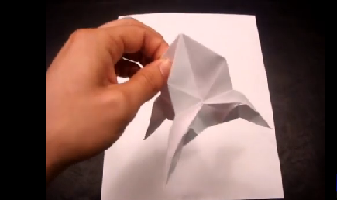
Students might enjoy this extension opportunity by taking advantage of a kinesthetic outlet.

Materials:
- Posters from Inspirational 'What's in a Quote Gallery Walk." You might want to take a picture to project these during this exercise or post the posters on a website.
- Two 8 1/2 inch x 11 inch sheets of paper. Computer printing paper is a good weight, or use Origami paper. (Only one sheet is needed, but an extra sheet might come in handy.)
- Pencil
- Scissors
Procedure:
Students should write the inspirational quote that caught their attention during the Gallery Walk on the paper they will be using. The paper will be cut to square it off and will provide the correct space for the quote. The directions for this are seen in the video 'How to Make and Origami Rocket Ship' provided in the Academy or by visiting the URL below:
https://www.youtube.com/watch?v=v1bv0RoJjzY

Closure:
Ask students to divulge their quotation, if they are willing. The connection and experience of the 'What's in a Quote' activity will be further embedded through this activity. They have a tactile product of inspiration!

