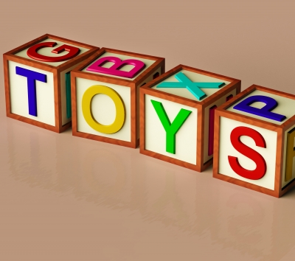
Toys in Space Lab
Purpose: To investigate the effect microgravity will have on the operation of toys in space and compare it with a toy's operation on Earth (1G).
Materials:
Toys in Space Video, various toys, observation sheet, timer, cell phone/video camera
Possible Toys (seen on STS 54):
Magnet Marbles Wind-up flip toys Velcro ball and target
Spring jumper Horse shoes and target Slinky
Racquet or pool balls Gyro game Gravitrons
Ball and Cup game Car and Track

Hypothesis: Write a hypothesis explaining what you think will happen with your toy in 1 G compared to what you observe with the same toy in microgravity observed from the Toys in Space video.
Procedure:
Students should watch the video and make notes about how the toys move in microgravity. Students are given two or three toys to work with from the video and a toy that is not from the video. Students then decide on a procedure to safely test the toys in 1 G as close as possible to the activity as seen in the video. Students test and videotape or record their toy's behavior. Students should make observations from their experiences and also use their video to help modify the experiments and to discuss them. Students can also record the time duration of the toy's activity.
Questions:
1. What did you observe with your toys on Earth that was similar to the experiences onboard STS 54?
2. What did you observe with your toys on Earth that was different than the experiences onboard STS 54?
3. What do you think was the main contributor to this difference? Support your statement with evidence.
4. How do you think living and working in microgravity will affect the tools humans use?
5. In order to have a successful space settlement outside of Earth:
a. What would be some possible modifications to some of the tools currently used in the construction business?
b. What would be some possible modifications to using the tools currently used in the medical business?
c. What would be some possible modifications to using the tools currently used around the house?
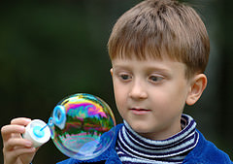
Toys in Space Data Sheet
Data Sheet for ________________________________ Date: ___________
Toy used | Behavior observed in microgravity | Duration of toy's movement | Behavior observed in  1 G | Duration of Toy's movement | Other observations  and comments
Toy not tested on STS 54: | What you think will happen in space: | Suspected duration:

Toys seen in the NASA "Toys in Space" Video:
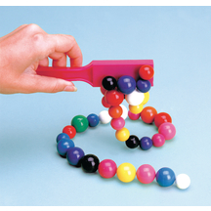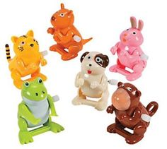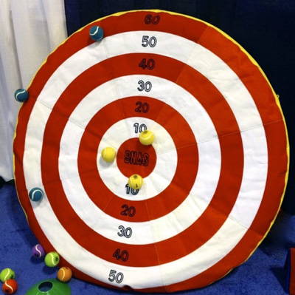
Magnetic Marbles
Wind up flip toys
Velcro target

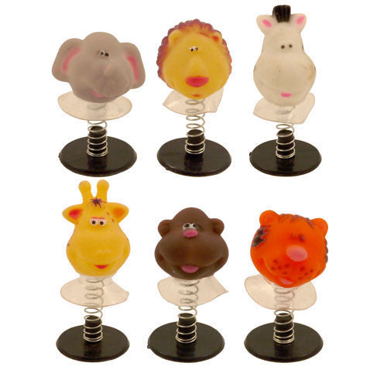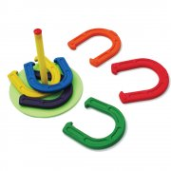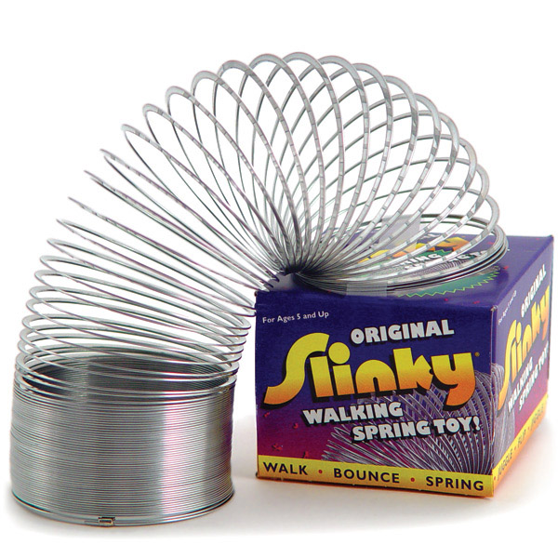
Horse Shoe Game

Slinky
Spring Jump Toy

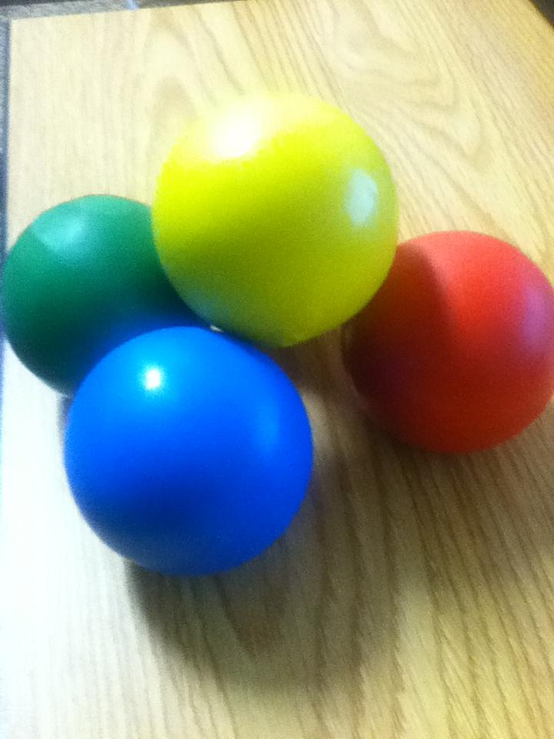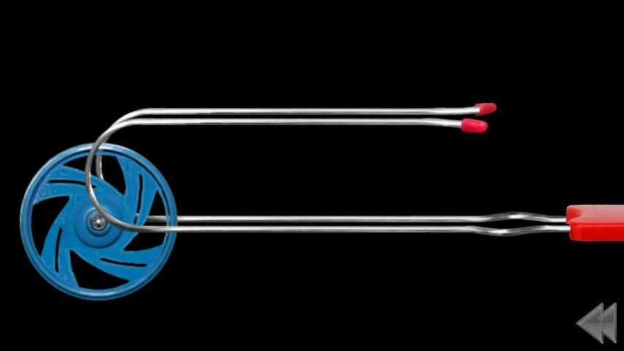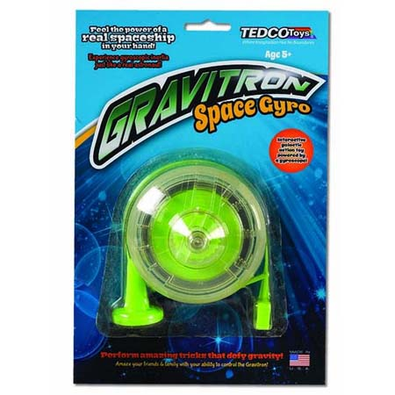
Gyro Toys
Racquet Balls
Gravitron

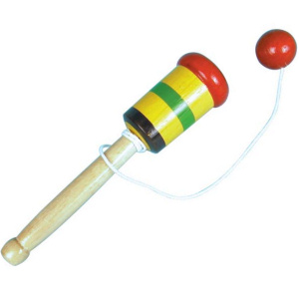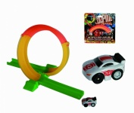
Ball and Cup Game
Car and Track

