Covering the Moon Model

After you have made the beginning or sub-form, the next step is to use Papier Mache to round out the crude ball shape. The following materials are needed

**Newspaper Strips Flour Water Peppermint Extract**

Make the Flour and water mixture very thin, about the consistency of milk. Add a few drops of the peppermint extract to the mixture and this will help to protect the final moon model from pests.

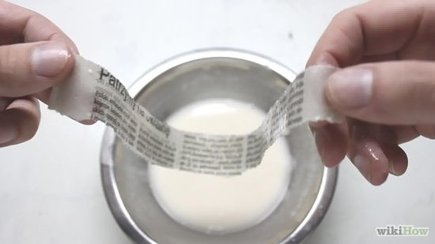

Dip the newspaper strips into the flour/water mixture and gently place them on the form you have made.

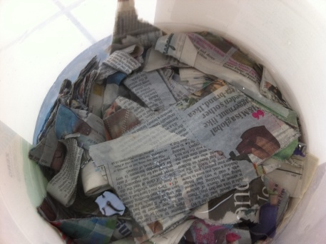Do this over the form, trying to make the moon model the shape of the chosen moon.

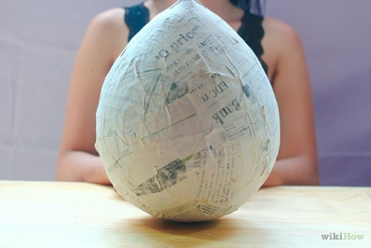Smooth the edges down using the mixture so you have a smooth surface.

Allow your project to dry for a couple of days.