Making a Moon Model Form

1. Make a beginning form:

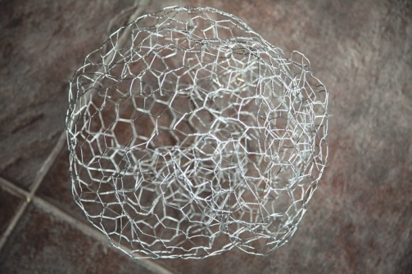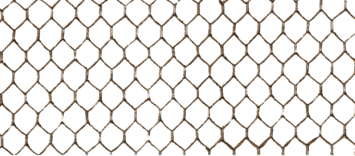A. A beginning form for the moon can be made from wire which is an open light weight wire. It is called chicken wire or poultry wire and is used to keep poultry in a fenced in area. You will need a pair of work gloves, pliers to bend and secure the ends, and wire cutters to cut the wire. If you use wire, you might want about 1 1/4 yards or 1.5 meters form it into a ball.

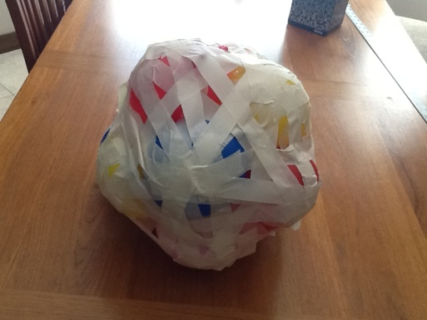B. An alternative to the wire, and an activity with more student -friendly materials uses a supply of balloons and masking tape. Use small inflated balloons and roll of masking tape. Use the tape to help form the balloons into a crude ball. Make a form that is about 15 - 18 inches or 30 - 45 cm.

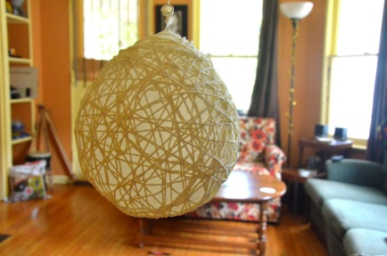C. Another alternative is to use a very large balloon, yarn, cornstarch

and water to make a form . This alternative will take another day or so than the alternatives A and B but is quite enjoyable for the students.

Alternative C instructions are given below.

In any case, bear in mind that the larger the form, the easier it will be to make the features of the moon visible and to scale. A completed form of about 18 inches or 30 cm inches is a good size for the form.

**Alternative C to Make a Moon Form:**

**Step 1: What You Will Need** http://www.instructables.com/id/Hanging-Yarn-Ball-Art-1/

[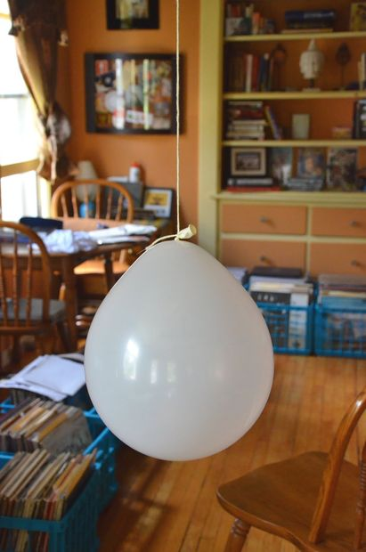](http://cdn.instructables.com/F3X/INNR/H1LWPH0R/F3XINNRH1LWPH0R.LARGE.jpg)  
-1 Bottle of Elmer's Glue -Corn Starch -Water -Measuring Cup  
- 100% Cotton Yarn - White -Fishing Line -Balloons (preferably large)  
  
*If you are doing this project inside you will need a shower curtain or large plastic sheet to help with the mess!  
This project will be a bit messy!  
  
**Step 2: Prepare your balloon:**

Start by hanging your balloons from the ceiling or on a rope tied between two chairs.  
Do not inflate the balloon to its fullest capacity if you want the balls to be round. Inflate it completely if you have an oval moon.  
Lay your shower curtain or plastic liner down. If you are outside you will not need something to catch the glue.

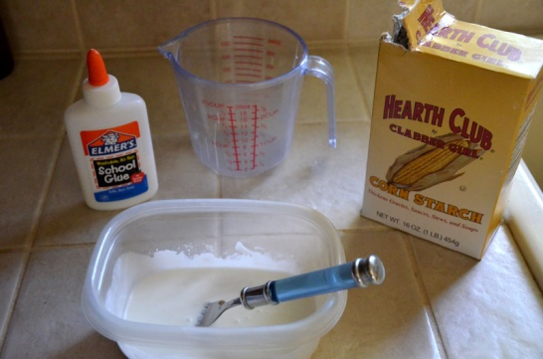 **Mix the Paste**

**Mix:**   
1/4 Cup of Water  
1/2 Cup of Corn Starch 1 Bottle of Elmer's Glue  
  
It should be runny, but not watery

**Step 4: Dip Yarn in Paste**

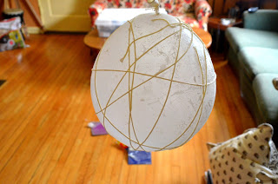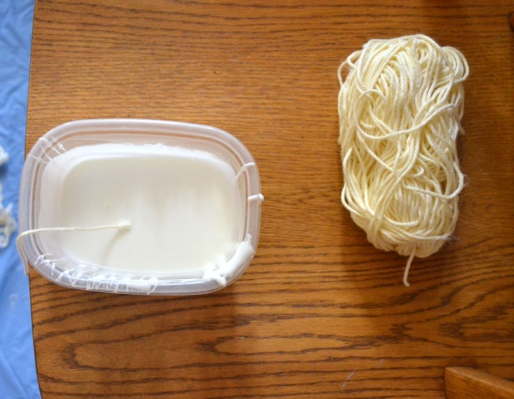  
Get the yarn wet in the paste.  
Either dip your fingers in the paste and cover the yarn or dip the yarn in the paste.  
Wrap the balloon with the paste soaked yarn until you are satisfied with how it looks.  
Allow the Balloons to dry for 12 hours or overnight to make sure they are completely dry.

**Step 5: Pop Balloon**

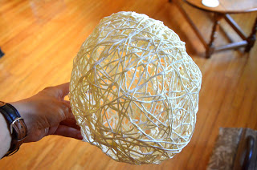Once the yarn balls are dry, pop the balloons and remove them from the yarn balls.  
You will have something that looks like this