**Moons graphics:** Encourage student s print out pictures of their moons from reliable sources and determine the size of the features. These are only a few possible selections.

**Iapetus (Saturn)**

[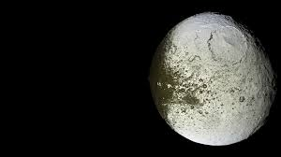](http://www.google.com/url?sa=i&rct=j&q=&esrc=s&source=images&cd=&cad=rja&uact=8&docid=WsL5obdJJt4z9M&tbnid=kpMF4eRlc8UB0M:&ved=0CAcQjRw&url=http://www.ggwallpaper.com/sitemap/sitemap5.xml&ei=DO0pVJ7gA4mryATV_YLADg&bvm=bv.76247554,d.aWw&psig=AFQjCNEfHV6S6PCS5Yl7ZVj3NcdXs3EggA&ust=1412120147521423)[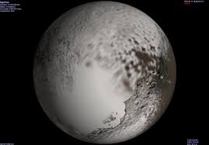](http://www.google.com/url?sa=i&rct=j&q=&esrc=s&source=images&cd=&cad=rja&uact=8&docid=101VB4SWjTOK7M&tbnid=TDZxB1m1JlZD0M:&ved=0CAcQjRw&url=http://descopera.truezone.ro/sistemul-solar-satelitii-lui-saturn/&ei=d-8pVL_XDYW0yATygoGQCg&bvm=bv.76247554,d.aWw&psig=AFQjCNHclNrP1Sl7P4abnSDeUuedDpwA3w&ust=1412120712505053)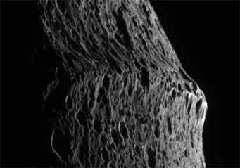

Page 2

**Hyperion (Saturn) Mimas (Saturn)**

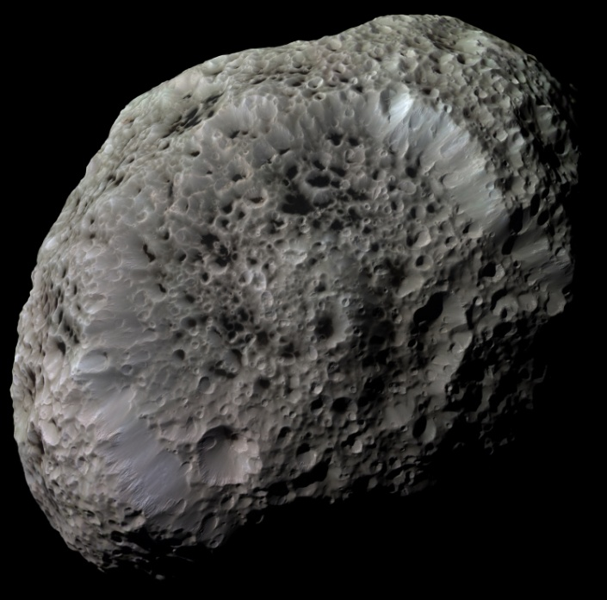 [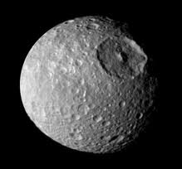](http://www.google.com/url?sa=i&rct=j&q=&esrc=s&source=images&cd=&cad=rja&uact=8&docid=101VB4SWjTOK7M&tbnid=TDZxB1m1JlZD0M:&ved=0CAcQjRw&url=http://pixgood.com/iapetus-moon.html&ei=6-8pVMWbOZD3yQTTk4GICQ&bvm=bv.76247554,d.aWw&psig=AFQjCNHclNrP1Sl7P4abnSDeUuedDpwA3w&ust=1412120712505053)

Page 3

**Enceladus(Saturn) Triton (Neptune)**

[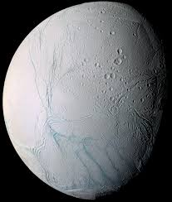](http://www.google.com/url?sa=i&rct=j&q=&esrc=s&source=images&cd=&cad=rja&uact=8&docid=1ZqcJ3BJrfCVBM&tbnid=ddSO2H8RZo_jkM:&ved=0CAcQjRw&url=http://en.wikipedia.org/wiki/Enceladus&ei=FfQpVMXRG4OsyAS3loH4DA&bvm=bv.76247554,d.aWw&psig=AFQjCNHpYi1bZMXWxO24qeS7MC_dySBn-g&ust=1412121998070098) 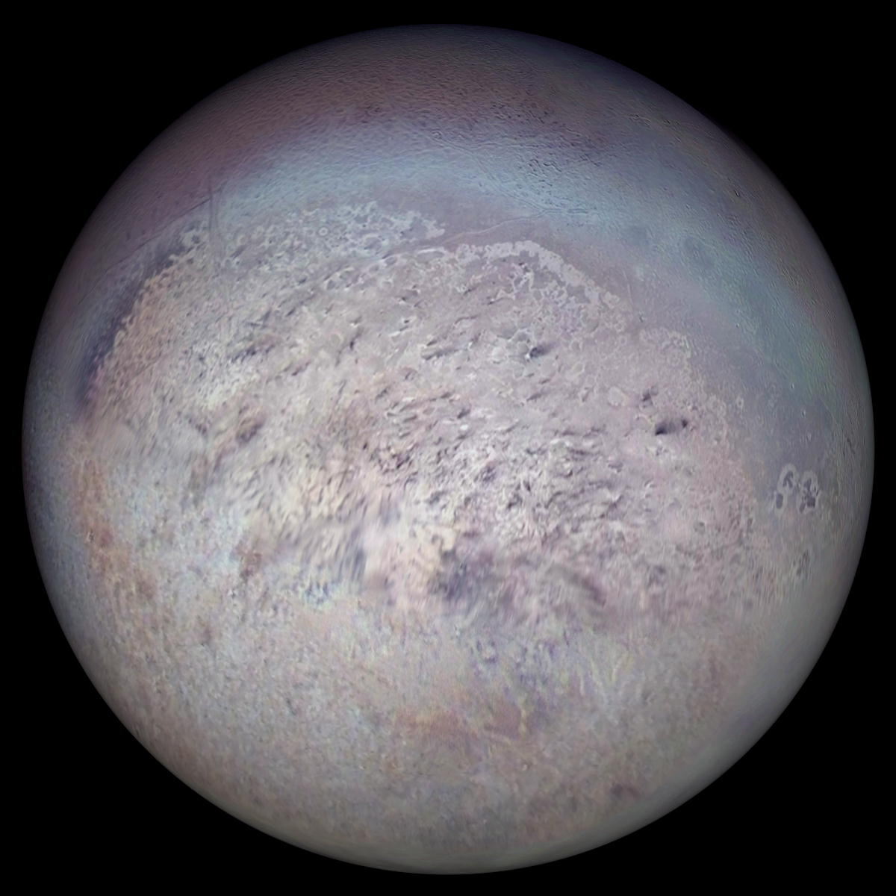

Page 4

**Ganymede (Jupiter)** **Phobos (Mars)**

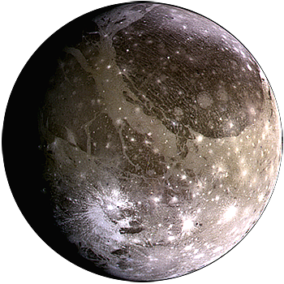 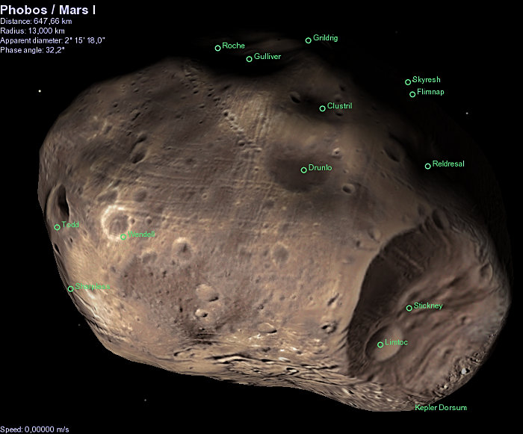

Page 5

**Titan (Saturn)** **Europa ( Jupiter)**

