Procedure for Construction of the Albedo Control Target:
The Albedo Control Target is used in the "Detecting Orbital Debris Using Albedo Lesson" found on the EIS Academy. The albedo detected from the Control Target will be compared to other models during the experiment.
Materials: Hexagonal Prism Template, 6 materials to attach to the template facets (felts, aluminum foil, materials of different textures, etc.), glue. Template can be found at: http://www.fun-stuff-to-do.com/support-files/hexagonal-prism-3d-geometric-shapes-to-fold.pdf
To make the Hexagonal Prism more rigid, use heavy card stock, and/or some Styrofoam cut in the shape of the hexagon (use template for sizing) that can be inserted inside the paper hexagon..
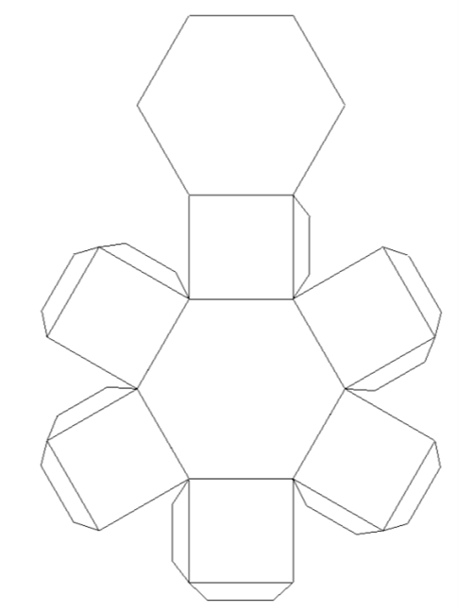
Procedure :
1. Print out the Template found below (in full scale) on card stock. You may wish to use a high weight card stock or reinforce the prism with additional rigid material like styrofoam.
Figure 1: Cut out Template

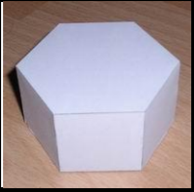
2. Assemble the hexagon by cutting out the template, folding all flaps, and securing the flaps with glue. If you are reinforcing the template, apply the reinforcement (Styrofoam, heavier weight paper, etc.) on the inside of the hexagon before sealing it. Allow the hexagon to dry.

Figure 2: Assembled Hexagon Template

3. Glue the different materials to the hexagon’s side facets and allow them to dry. This completes construction of the Albedo Control Target.
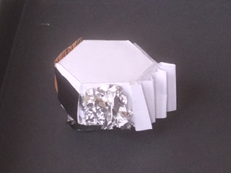
Here are some examples of a completed control target:
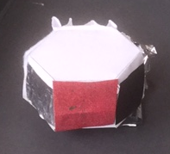
Figure 3:.Control Target. View A Figure 4: Control Target View B
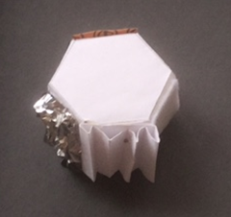
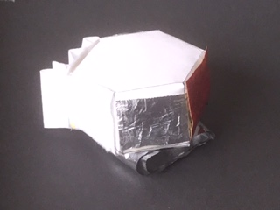

Figure 5: Control Target View C Figure 6: Control Target View D
4. Attach the Albedo Control Target to the Albedo Detector Spinner by pushing it into the screws protruding from the spinner or by using tape to secure it to the spinner. Test to see that the Albedo Control Target will be stable as it spins during data collection via the Light Grapher. (Directions for making the spinner are also available on the EIS Academy.)
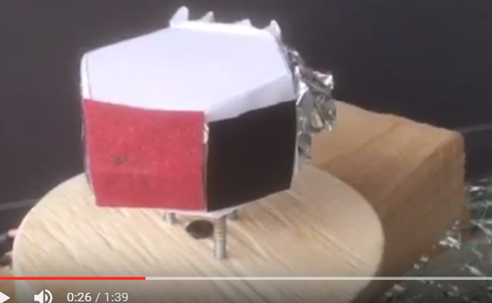

Figure 7: Control Target on Spinner View 1

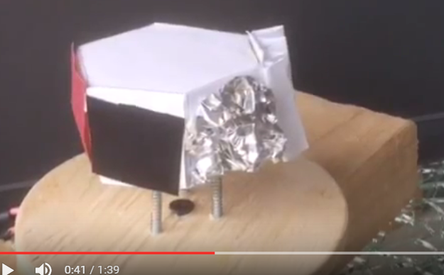

Figure 8: Control Target on Spinner View 2

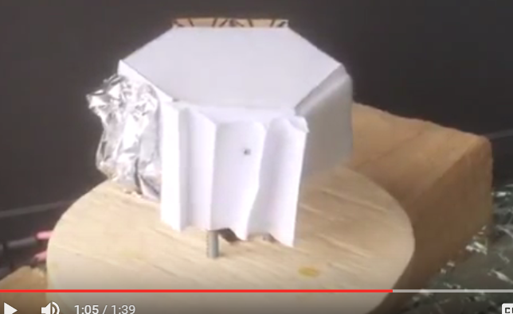

Figure 9: Control Target on Spinner View 3

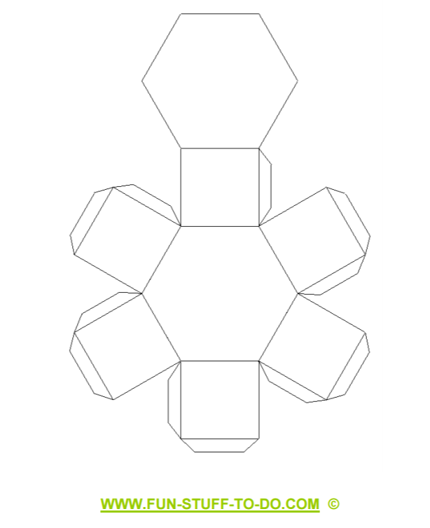
Albedo Control Target Template

