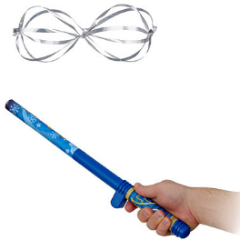**FunFlyers and Electric Charge Observation Worksheet**

**Experimenters: ______________________________________**

Record your observations to the following questions:

|  |
| --- |
| 1. When do you notice the FunFlyer being repelled? |
| 2. a. When do you notice the FunFlyer being attracted to something?  b. What does it seem to be attracted to? |
| 3. What happens when you place the FunFlyer between your hand and the wand? |
| 4. a. What happens when you touch the expanded FunFlyer?  b. Why is this? |
| 5. a. What happens when you bring two FunFlyers close together operated by different people?  b. Why does this happen? |
| 6. a. Touch the activated wand to a person with rubber soled shoes while they are holding the FunFlyer. What do you observe?  b. Why is this happening? |
| 7. a. When your FunFlyer sticks to the wall, what happens after a period of time?  b. Explain why this happens. |

**Optional Extension Questions:**

1. Why does the Mylar object have to touch the tip of the wand before it can float around the wand?
2. Explain why the Mylar floats around the electrostatically charged wand.
3. At what distance is the floating Mylar object the most repelled to the wand? Explain how you came to this conclusion.
4. Why is the Mylar attracted to objects that do not have a charge, like the walls, ceiling, and you?
5. Why are the floating Mylar objects not attracted to each other?
6. How does this activity connect to a spacecraft being electrostatically charged as it moves through space?
7. Why do you think scientists turn their satellites off when a CME (Coronal Mass Ejecta) approaches Earth?
8. How does this activity connect to the creation of the aurora?  (Hint you will need to go through the Dawn of the North tutorial found on the EIS Academy, www.eisacademy.org).

The Fun Fly Stick used in the workshop is made by Unitech Toys.