**Making a Cloud Chamber Using a Plastic Cup**

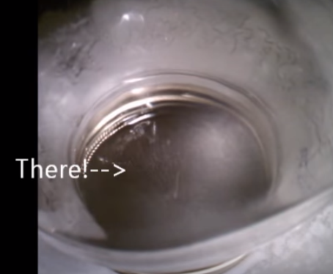

A cloud chamber shows the effect that cosmic charged particles have on a saturated mist of isopropyl alcohol as the charged particles move through the mist, ionizing atoms in its path. The alcohol molecules clump and stick together to form tiny droplets that appear as a type of contrail in the mist.

Materials: (per chamber)

Stiff felt Plastic Cup (14 oz) Modeling Clay (5 oz) Cookie Sheet or Metal Shallow Lid

Styrofoam Sheet Frozen Carbon Dioxide (Dry Ice) Goggles and Gloves

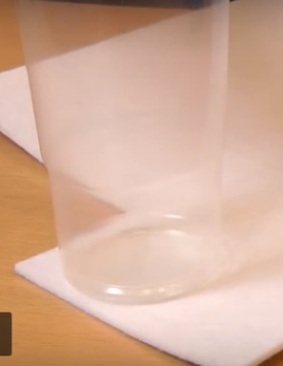

Procedure:

1 . Cut a piece of the stiff felt so that it fits in the bottom of the plastic cup and push it in place at the bottom of the cup.

2. Roll out two pieces of the modeling clay, one longer than the other.

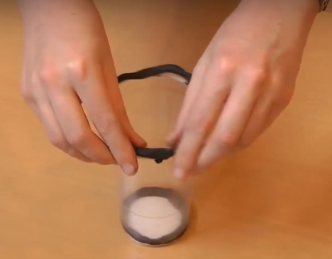3. Use one of the rolls to secure the felt in the cups bottom so that when inverted, the felt does not fall out.

4. Press the larger roll around the rim of the cup. This will form a seal when inverted later.

5. Add the alcohol to the felt until it is highly saturated and can hold no more alcohol.

6. Add dry ice to the cookie sheet or lid, put the Styrofoam sheet on top of the cookie sheet, and invert the cookie sheet or lid onto the Styrofoam sheet.

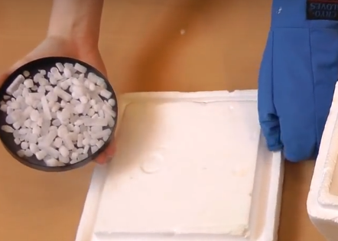7. Invert the alcohol saturated cup onto of the inverted cookie sheet.

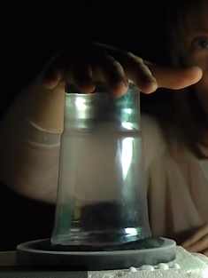

8. Invert the alcohol saturated cup onto the lid or cookie sheet, turn off the lights, use a light source near the inverted cup and watch for the cosmic ray ‘contrails.’

(Source: How to Make a Cloud Chamber: <https://video.search.yahoo.com/yhs/search;_ylt=A0LEVvVSZdtZ8isAXRwPxQt.?p=cloud+chamber+in+a+jar&fr=yhs-itm-001&fr2=piv-web&hspart=itm&hsimp=yhs-001&type=mnn_frmr_17_37#id=3&vid=8d29be9080a0ccbcdbc4b8c0461368cf&action=view>