

|  |
| --- |
| **Lesson Summary**  Excellent instructions on making and using a simple magnetometer and using it to establish solar activity |
| **AAAS Science Benchmarks**  **The Nature of Science**  *Scientific Inquiry*  **The Nature of Technology** |
| *Technology and Science* |
| **The Physical Setting** |
| *Forces of Nature* |
| **NGSS (Next Generation Science Standards)** |
| **Science as Inquiry**  *Abilities to do Scientific Inquiry Understandings of Scientific Inquiry* **Physical Science**  *Motions and Forces, Waves/Electromagnetic Rad* |
| **Earth and Space Science** *Earth in the Solar System* **Science and Technology**  *Understandings about Science and Technology*  **History and Nature of Science**  *Science as a Human Endeavor* |
| *Nature of Science* |
| **CCSS Mathematics Standards** |
| **Geometry Measurement** |
| **Data Analysis & Probability Problem Solving** |



*Solar Storms and You! Exploring Magnetic Storms*, pp. 18-20, NASA EG-2000-03-002-GSFC <http://image.gsfc.nasa.gov/poetry/higley.html>

**Teaching Time**: Two or three 45-minute period

**Materials per Magnetometer**

•

•

•

•

•

•

•

•

•

•

•

2L clear plastic container 2’ sewing thread

Bar magnet 100 mm x 7 mm 3” x 5” index card

Mirrored sequin

Bright lamp or laser pointer Scissors

Meter stick Super Glue

1” of soda straw Large sheet of paper

(1)

(2)

(1)

(1)

(1)

**Advanced Planning Preparation Time**: 20- minutes

1. Review lesson plan
2. Build and use a simple magnetometer
3. Practice mapping ambient field

***Editor’s Note***

*This lesson contains the best set of images and directions for assembly of the simple magnetometer used in many similar activities described throughout this guide.*

**Teacher’s Guide A Soda Bottle Magnetometer**

Solar storms can affect the Earth’s magnetic field causing small changes in its direction at the surface which are called magnetic storms. A magnetometer operates like a sensitive compass and senses these slight changes. The soda bottle magnetometer is a simple device that can be built for under $5.00 which will let students monitor these changes in the magnetic field that occur inside the classroom. When magnetic storms occur, you will see the direction that the magnet points change by several degrees within a few hours, and then return to its normal orientation pointing towards the magnetic north pole.

**Introduction**

**Objective**

The students will create a magnetometer to monitor changes in the Earth’s magnetic field for signs of magnetic storms.

**Procedure**

**Materials**

1. Clean the soda bottle thoroughly and remove labeling.
2. Slice the bottle 1/3 way from the top.
3. Pierce a small hole in the center of the cap.
4. Fill one quarter of the bottom section with sand.
5. Cut the index card so that it fits inside the bottle. (See Figure 1)
6. Glue the magnet to the center of the top edge of the card.
7. Glue a 1-inch piece of soda straw to the top of the magnet.
8. Glue the mirror spot to the front of the magnet. (See Figure 2)
9. Thread the thread through the soda straw and tie it into a small triangle with 2-inch sides.
10. Tie a 6-inch thread to top of the triangle in #9 and thread it through the hole in the cap.
11. Put the bottle top and bottom together so that the ‘Sensor Card’ is free to swing with the mirror spot above the seam. (See Figure 2)
12. Tape the bottle together and glue the thread through the cap in place.
13. Place the bottle on a level surface and point the lamp so that a reflected spot shows on a nearby wall about 2-meters away. Measure the changes in this spot position to detect magnetic storm events. (See Figure 3 and 4)

# —One clean 2-liter soda bottle

—2 pounds of sand

—2 feet of sewing thread

—A small bar magnet

—A 3x5 index card

—A 1-inch piece of soda straw

—A mirrored dress sequin

—Super Glue (be careful!)

—2-inch clear packing tape

—A meter stick

—An adjustable high intensity lamp

**Conclusion and Tips:**

# Just as students may be asked to monitor their classroom barometer for signs of bad weather approaching, this magnetometer will let students monitor the Earth’s environment in space for signs of bad space weather caused by solar activity. NASA EG-2000-03-002-GSFC Exploring Magnetic Storms

It is important that when you adjust the location of the Sensor Card inside the bottle that its edges do not touch the inside of the bottle and that the mirror spot is above the bottle seam and the taping region of this seam so that it is unobstructed and free to spin around the suspension thread.

The magnetometer must be placed in an undisturbed location of the classroom where you can also set up the high intensity lamp so that a reflected light spot can be cast on a wall within two meters of the center of the bottle. This allows a one-centimeter change in the light spot position to equal ¼ degree in angular shift of the north magnetic pole. At half this distance, one centimeter will equal ½ degree. Because magnetic storms produce shifts up to 5 or more degrees for some geographic locations, you will not need to measure angular shifts smaller than ¼ degrees. Typically, these magnetic storms last a few hours or less.

To begin a measuring session which could last for several months, note the location of the spot on the wall by a small pencil mark. Measure the magnetic activity from day to day by measuring the distance between this reference spot and the current spot whose position you will mark, and note with the date and the time of day. Measure the distance from the reference mark and the new spot in centimeters. Convert this into degrees of deflection for a two-meter distance, by multiplying by 1/4 degrees for each centimeter of displacement.

You can check that this magnetometer is working by comparing the card’s pointing direction with an ordinary compass needle which should point parallel to the magnet in the soda bottle. You can also note this direction by marking the position of the light spot on the wall.

If you must move the soda bottle, you will have to note a new reference mark for the light spot and then resume measuring the new deflections from the new reference mark as before.

Most of the time there will be few detectable changes in the spot’s location so you will have to exercise some patience. The activity of the sun varies. If a solar maximum is approaching, the number of magnetic storms will increase. * Large magnetic storms are accompanied by major auroral displays, so you may want to use your magnetometer in the day time to predict if you will see a good auroral display after sunset. Note: Professional photographers use a similar device to get ready for photographing aurora in Alaska and Canada.

For more information about how to conduct this experiment, visit the NASA, IMAGE satellite web site’s ‘Join Magnet!’ page at http://image.gsfc.nasa.gov/poetry

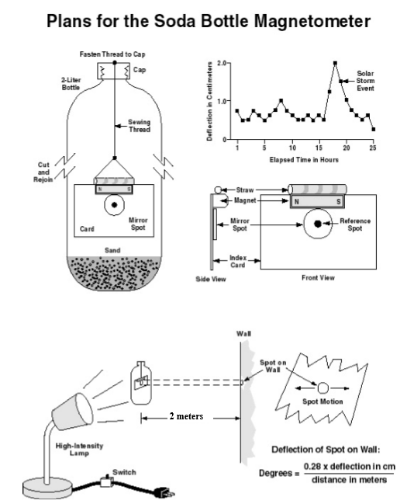

Figure 1

Figure 4

Figure 3

Figure 2