About us
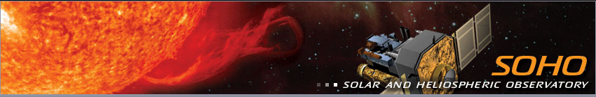

Measuring the Motion of a Coronal Mass Ejection

Here we calculate the velocity and acceleration of a coronal mass ejection (or CME) based on its position in a series of images from the LASCO (The Large Angle and Spectrometric Coronagraph) instrument on SOHO (Solar Heliosphere Observatory).
A coronal mass ejection occurs when a significant amount of relatively cool, dense, ionized gas escapes from the normally closed, confining, low-level magnetic fields of the Sun's atmosphere to streak out into the interplanetary medium, or heliosphere. In other words, a large quantity of mass is accelerated by the magnetic field of the corona and travels through space, sometimes towards the Earth. Eruptions of this sort can produce major disruptions in the near Earth environment, affecting communications, navigation systems and even power grids. SOHO with its uninterrupted view of the Sun and allow a better understanding of how such violent events occur.

Materials:
If you are doing this on paper you will need
- SOHO CME IMAGES
- ruler
- calculator
- Select a feature that you can see in all five images, for instance the outermost extent of the bright structure or the inner edge of the dark loop shape. Measure its position in each image. Measurements on the screen or page can be converted to kilometers using the simple ratio:
d_{screen}/d_{actual}= s_{screen}/s_{actual}
where:
d_{screen} is the diameter of the Sun measured on the screen.
d_{actual} is the actual diameter of the Sun.
s_{screen} is the position of the mass as measured on the screen.
s_{actual} is the actual position of the mass.
The diameter of the Sun = 1.4 × 10⁶ (1.4 million) km.
- Using the position and time, you can calculate the average velocity. Velocity is defined as the rate of change of position. Using the change in position and the change in time, the average velocity for the time period can be calculated using the following equation:
v = (s₂ - s ₁)/(t₂ - t₁)
where:
s₂ is the position at time, t₂.
s₁ is the position at time, t₁.
The acceleration is the change in time of the velocity:
a = (v₂ - v ₁)/(t ₂ - t₁)
where:
v₂ is the velocity at time, t₂.
v₁ is the velocity at time, t₁.

- You can record your results in a table:
(This Activity was adapted from ESA and NASA)
Data Table for CME Information (choose your images):
Universal Time | Time Interval | Position | Average Velocity | Average Acceleration
 | _ | _ | _ | _
 | _ | _ | _ | _
 | _ | _ | _ | _
 | _ | _ | _ | _
 | _ | _ | _ | _

Further Questions and Activities
Select another feature, trace it, and calculate the velocity and acceleration. Are they different from those for the last feature you selected?
Which one is "right"? Scientists often look at a number of points in different parts of the CME to get an overall idea of what is happening.
Sometimes it can be tough to trace a particular feature. How much error do you think this introduces into your calculations?
How does the size of the CME change with time?
What kind of forces do you think might be acting on the CME? How would these account for your data? These are important questions in CME research!
Exploring SOHO data
If you look at the data available from LASCO in the SOHO Gallery and elsewhere, you will see that the images usually have a circle in the center of the coronagraph disk representing the size and position of the Sun. Using this to find the scale of the image, you can make calculations similar to the one you just did for most sequences of LASCO images.
LASCO also observes comets. You can measure their velocities and accelerations too.

