**Cloud Chamber/Particle Chamber**:

Objective: To observe the presence of particle paths made by cosmic rays to reinforce the idea that Earth is being bombarded by particles from cosmic rays.

Materials:

Plastic acquarium with dark lid, felt and glue, brackets to attach to floor of acquarium,

Isopropyl alcohol (IPA), Squeeze bottle, Dry Ice, Plastic container to hold dry ice,

Gloves to handle dry ice, Tape to hold Insulating Styrofoam in place,

Styrofoam to insulate container on floor and sides of container,

Vaseline petroleum jelly to put on edges of acquarium to help seal the acquairum onto the lid,

Strong Light Source

1.Get a clear plastic tube, like an acquarium that has felt bracketed/glued onto bottom - light color is good.

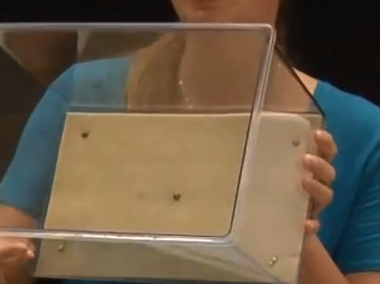

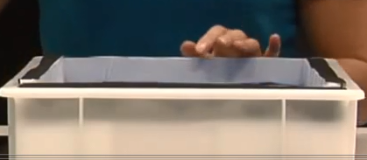2. Get a dark lid/base for the aquarium. A metal one is good.

3. Get a plastic bin to hold the items. Put styrofoam around the sides and bottom to insulate it. Place the dry ice in the bin.

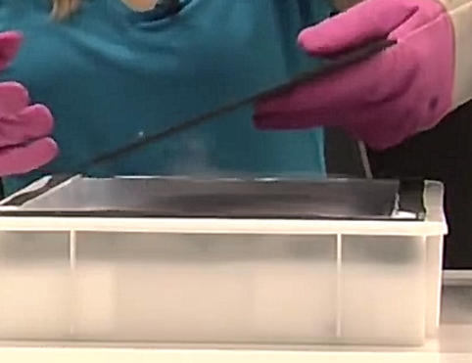4. Dampen the felt thoroughly with the IPA, but not enough to have free liquid overflowing or dripping.

5. Put the metal cover to the aquarium over the dry ice. If there is extra IPA, drip it on to the cover.

6. Spread Vaseline around the acquarium and invert it onto the acquarium lid above the dry ice.

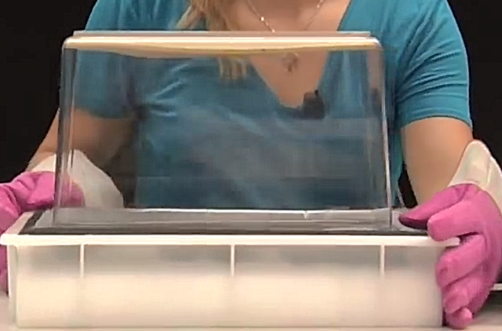

7. Wait a few moments while the warm IPA (It is very volatile, molecules move quickly, so there's lots of energy and heat in the IPA) is evaporting into the chamber. It settles down towrd the dry ice and condences. Any disturbance in the air from these moving molecules will create a cloud.

As the cosmic rays hit the chamber, they ionize the gas molecules in the chamber and all the IPA molecules now clump and stick together to form tiny droplets.

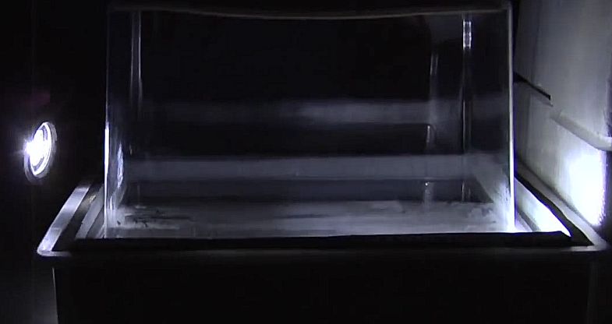8. Swith off the lights and use a strong light source shining from the side of the chamber.

Explanation/description of particles:

Fat Streaks - Radon atoms that are spitting out alpha particles. (During radioactive decay, they emit a Helium nucleus which is an alpha particle.)

Long, staight tracks : Muons which are heavier, when they go through the air, they are not easily deflected because of their heavier mass.

Curly cue, zig-zag streaks: electrons & positrons which are smaller and easily deflected. They bounce off of othr particles they run into.

