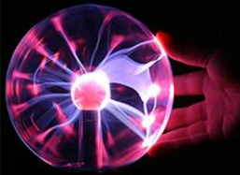**Working with a Plasma Ball**

**Session: Oct. 28, 2017 Carthage College**

**Electrostatics and Space!**

**Course material: Astronomy: The nature and behavior of stars, i.e. coronal mass ejecta, electrostatic charges in space**

**Background:** We have studied that our sun produces plasma (charged particles) and sends out coronal mass ejecta. More than 99% of the matter in the universe is plasma. Plasma is also seen on earth in flames, lightning, and fluorescent tubes. We have seen beautiful pictures of intergalactic nebula and the aurora borealis that is plasma. In this lab we will have an opportunity to observe plasma and some of its behaviors through the use of a plasma globe.

A plasma lamp is usually a clear glass orb filled with a mixture of various gases (helium and neon, sometimes with other noble gases such as xenon and krypton) and driven by a current. A much smaller orb in its center serves as an electrode. The electric field is strong enough to ionize the gases in the ball (it pulls their electrons off) and the freed electrons undergo collisions which liberate more electrons from other gas molecules. Plasma filaments extend from the inner electrode to the outer glass insulator, giving the appearance of multiple beams of colored filaments. The beams initially follow the electric field lines of the dipole but move upwards due to convection.

**Objective: To observe and investigate the behavior of plasma**

**Part A: Observing plasma in a plasma globe.**

**Materials: Plasma ball, wood, plastic, metal, paper, fabric, glass beaker, closed vial of water, meter stick, magnet, fluorescent tube, darkened room.**

**Procedure: Plasma Balls are delicate, please work with them carefully!**

**1. Turn on plasma globe.**

**2. Test the effect of objects on the plasma ball.**

**Record observations in table with several scenarios starting with just turning the globe on and using not external objects against the globe. Record the behavior seen in the globe. Now test the effect objects will have on the plasma streams in the globe using the suggested items as well as any other safe items. Bring the object against or next to the globe carefully. Observe the colors and where you see them, the number of plasma lines seen, the intensity or color or size of the plasma stream. Record your observations in the Observation Sheet. Carefully experiment with the equipment to investigate how to change the display that you see. Avoid objects becoming hot.**

**Part A - Observation Sheet**

|  |  |
| --- | --- |
| **Item** | **Behavior observed** |
| **No additional items** |  |
| **One finger then multiple fingers** |  |
| **Your hand** |  |
| **A wooden block** |  |
| **A paper product** |  |
| **Something made of plastic** |  |
| **A glass beaker** |  |
| **A closed vial of water** |  |

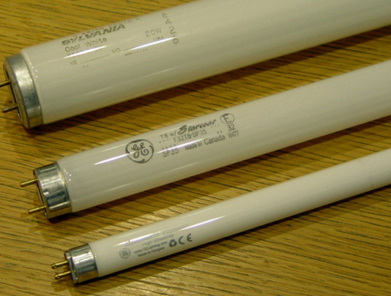**Part B: Observing the behavior of a fluorescent bulb near plasma.**

**Materials: Plasma globe, fluorescent bulb, magnet**

**1. Turn on plasma globe.**

**2. Carefully bring the fluorescent bulb close to the globe. You may gently touch the tube to your globe. Make observations.**

**3. Experiment with holding the bulb at various locations.**

**4. Experiment with the distance from the globe at which the bulb is lighted. Once the bulb is lit, does it keep the energy as it is moved away from the globe?**

|  |  |
| --- | --- |
| **What happens as you bring the bulb close to the globe?** |  |
| **What happens when you have your hands close together holding the bulb to the globe?** |  |
| **What happens as you touch the tube to the globe and hold the bulb at the far end?** |  |
| **What happens as you hold your hands close together on the bulb and then increase the distance between your hands as they move down the globe?** |  |
| **Experiment with how far you can hold the bulb from the globe to get it to light and also to lose its light. Record your findings.** |  |