Ionization Tubes Experiment Name: ____________________________

Background: Plasma is gas that has been energized to such a state that the electrons in orbit around the atoms of the gas are moving freely and are separated from the atom so the atom becomes ionized, it now carries a charge. In an ionization tube, the scenario is the same. An electric charge travels through the vacuum tube that excites the electrons of the atoms of the gas. When the electrons fall from this energized state to a more stable state, a glow is emitted that carries a particular color for the type of gas that has been ionized. This experiment investigates the colors of the once energized gases.

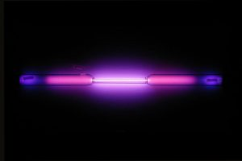Objective: To understand that different plasma gases can carry unique colors.

Procedure: Materials: Ionization tubes, Power Source, Gloves, Data Sheet

1. Record the color of the ionization tube gas.

2. Carefully engage the ionization tube into the Power Source. Turn on the electricity and watch as the gas is ionized. Record the color as best you can in the table below.

3. Using gloves, turn off the Power source and remove the hot tube from the source, carefully placing it in a safe place. Continue with the next tube. https://sciencenotes.org/argon-facts

Data Table:

|  |  |  |  |
| --- | --- | --- | --- |
| Type of Tube | Color of contents before energized | Color of contents after energized | Energized Atoms |
| Water H2O |  |  |  |
|  |  |  |  |
|  |  |  |  |
|  |  |  |  |
|  |  |  |  |

**Questions for you:**

**1. What does it take for matter to move from one state to another?**

**2. Our sun produces plasma through fusion. What makes the sun stay together rather than all the plasma just blow away from the sun?**

**3. What is plasma?**

**4. How does the activity with the ionization tubes help you to understand plasma behavior in space and on earth?**