**Medical Terms Defined:**

These cells are noted in the degree of sensitivity to plasma radiation.

**Endothelial cells** – line inside of blood vessel

**Erythroblast** -  A cell that contains hemoglobin and can carry oxygen to the body

**Fibroblast** - the most common cells of connective tissue in animals.

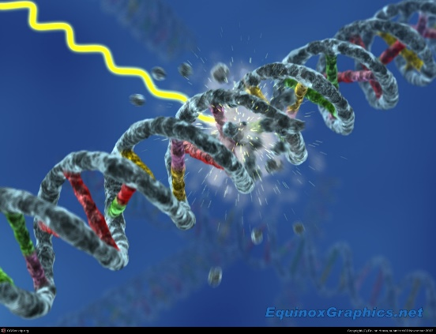**Lymphocytes**- subtypes of white blood cell

**Osteoblast** – large cell in bone formation

**Spermatids** – immature sperm cells

**Spermatogonia**-undifferentiated male germ cell;  capable of functioning in fertilization or conjugation and contains the haploid number of chromosomes of the organism

**Stem Cells-**  undifferentiated biological cells that can differentiate into specialized cells and can divide (through mitosis) to produce more stem cells

**Undifferentiated Cell –** A cell resembling an embryonic cell in that it does not have the specific morphologic or  functional characteristics of any particular adult cell type

**Ionizing radiation** **-** radiation composed of particles that carry enough energy to liberate electrons from atoms or molecules without raising the temperature of the material. Ionizing radiation is generated through nuclear reactions, by very high temperature (e.g. the corona of the Sun), in particle accelerators, or due to charged particles acceleration in electromagnetic fields produced by natural processes, for example, during lightning.

**Radiation. Absorbed Dose**

The **absorbed dose** characterized the amount of damage done to the matter (especially living tissues) by ionizing radiation. The absorbed dose is more closely related to the amount of energy deposited.

The SI unit of absorbed dose is the **gray** (Gy), which is equal to J/kg. 1 gray represents the amount of radiation required to deposit 1 joule of energy in 1 kilogram of any kind of matter. The **sievert (Sv)** is the International System of Units (SI) derived unit of equivalent radiation dose, effective dose, and committed dose. One sievert is the amount of radiation necessary to produce the same effect on living tissue as one gray of high-penetration x-rays. Quantities that are measured in sieverts are designed to represent the biological effects of ionizing radiation.

**One** **radiation absorbed dose**, or **rad** - corresponds to the absorption of 10-5 joules of energy per gram of body weight. Because this is equivalent to 0.01 J/kg, one rad produces an increase in body temperature of about 2 x 10-6C. At first glance, the rad may seem to be a negligibly small unit of measurement. The destructive power of the radicals produced when water is ionized is so large, however, that cells are inactivated at a dose of 100 rads, and a dose of 400 to 450 rads is fatal for the average human.

**REM and RBE-** a REM (Roentgen Equivalent man) defined as the dosage in rads that will cause the same amount of biological injury as one rad of X rays or gamma rays. Formerly poorly defined, the rem was redefined in 1962 to clarify the usage of the term relative biological effectiveness (RBE) in both radiobiology and radiation protection. **rems = rads x RBE**