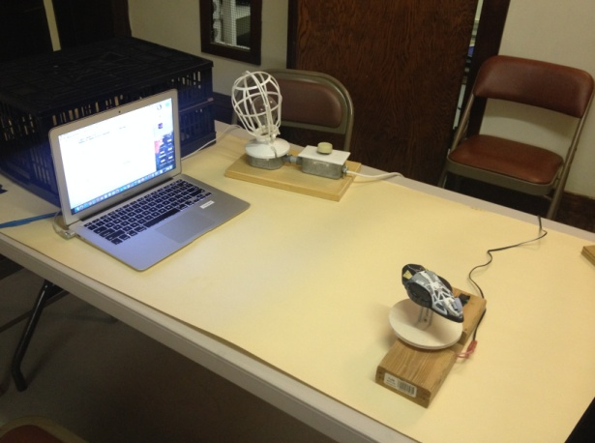
Albedo Experiment Worksheet - Part 1

Purpose:

The purpose of this activity is to learn how scientists use light curves to sense the reflected brightness, called albedo, from objects of different color, shape, and texture. This is a technique used to simulate the detection and tracking of asteroids and orbital space debris. Part 1 of this activity will concentrate on studying a set of known surfaces to determine how they might be used to characterize and identify various types of orbital debris.

Materials:

Albedo Detector Spinner, Procedure for Light Grapher, light source, Albedo Control Target (hexagon), and ball. Computer or device with access to camera and Light Grapher via this link:
https://kepler.nasa.gov/education/ModelsandSimulations/lightgrapher/

Procedure:

- Your group will use an Albedo Control Target (hexagon) as a standard control target to compare against the experimental targets that simulate a piece of man-made or natural orbital debris
- Attach the Control Target to the Albedo Detector Spinner. Describe each hexagon face in Table 1 below. Start the Light Grapher, filling in the exposure time range and any observations in the table. (Reference the Light Grapher Instructions document for the procedure on how to synchronize revolution time. Instructions for making the Control Target and the Albedo Detector Spinner are found on the EIS Academy.)
- Repeat steps 1 and 2 using a ball as your target.
- Print out copies of your two albedo graphs. Bracket or section off and label the six surfaces on the hexagon control target graph.

Data
Table 1 - Albedo Control Target

Face Number | Face Description | Exposure Time  Range  (From __ sec to ___ sec) | Observation
1
2
3
4
5
6
Ball
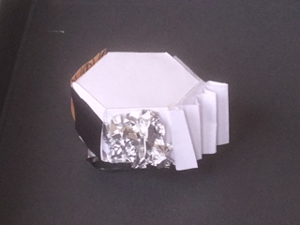
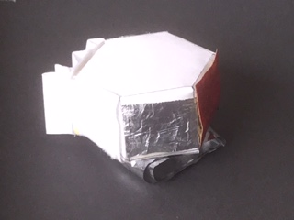

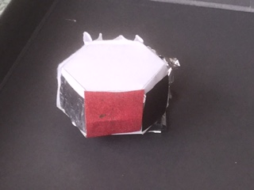

Analysis- Control Target Questions

- Describe what the albedo light curve for the ball looked like.
- What do you think the albedo light curve of the ball tells us about the ball and what evidence do you have to support your claim?
- Is there any evidence from the light curve of the ball that indicates it is rotating?
- What type of graph is produced by dark surfaces compared to light colored surfaces?
- When you analyze the albedo graphs, how does the texture of the silver foil flat surface compare to the silver foil crinkled up surface?
- How does the graph of the variegated white paper surface compare to the flat white felt surface?
- How does the graph of the sandpaper surface compare to the foil crinkled up surface?
- How can albedo be used to identify materials?
- Which surfaces produced smooth light curves?
- Which surfaces produced sharp peaks in the light curve?
- What are some of the things that you noticed during your light curve investigations that were interesting or unexpected?

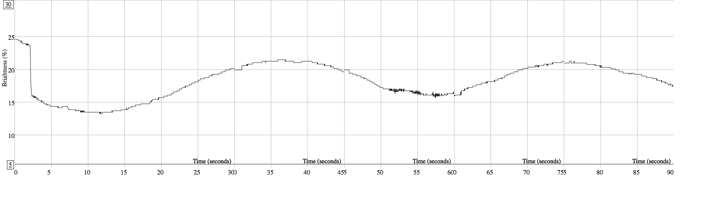

Conclusion:

Explain the similarities and differences in shape, color, and texture of the albedo light curves generated from the ball and six control surfaces, and how these similarities and differences might be used to characterize and identify various types of orbital debris.

Albedo Experiment Worksheet - Part 2

Purpose:

The purpose of this activity is to learn how scientists use light curves to sense the reflected brightness, called albedo, from objects of different color, shape, and texture. This is a technique used to simulate the detection and tracking of asteroids and orbital space debris. Part 2 of this activity will utilize the data from Part 1 to better understand how orbital debris can be identified.

Materials:

Albedo Detector Spinner, Procedure for Light Grapher, light source, an Experimental Target (potato, spaceship model, asteroid models, winter/gardening gloves, paper spacecraft models, etc.) Computer or device with access to camera and Light Grapher via this link:
https://kepler.nasa.gov/education/ModelsandSimulations/lightgrapher/

Procedure:

- Choose a target object to analyze.
- Fill out Table 2A below to predict or make a claim about what you think the albedo curve will look like
- Attach the Experimental Target to the Albedo Detector Spinner, and start the Light Grapher. (Reference the Light Grapher Instructions document for the procedure on how to synchronize revolution time.)
- Fill out Table 2B to analyze the experiment data from Table 2A
- You can repeat procedures 1-4 using the additional tables (Table 3A & 3B, Table 4A & 4B) provided for other Experimental Target Objects.
- Print out copies of your albedo graphs

Data: Table 2A - Albedo Experiment Target Data
Target Object Name
Hypothesize graph characteristics you think you might see

What elements or evidence from the control analysis in Part 1 are you using to support your hypothesis?

Sketch the graph shape you anticipate

Optional Comments

Analysis: Table 2B - Albedo Experiment Target Analysis

Target Object Name
Explain how the hypothesis from Table 2A compared to the actual results

Where in your graph and from what surfaces did the control match the actual surface of the experiment target?

Explain how well the predicted graph matched the actual graph

Other Comments

Analysis: Experimental Target Questions

- In what ways did the control graph compare to each of the target object graphs your team tested?
- How well did using the data from the control help you to match surfaces on the target object?
- Which type of target was the easiest to identify using the graph and why?
- Which type of target was the hardest to identify using the graph and why?
- In what ways would it be easy or difficult to identify a piece of orbital debris using this technique?
- What are some of the things that you noticed during your light curve investigations that were interesting or unexpected?

Conclusion:

Explain how light curves from a set of control surfaces can be used to sense the reflected brightness or albedo from objects of different color, shape, and texture. Explain how scientists might use albedo light curves to detect, identify, and track orbital space debris.

Data: Table 3A - Albedo Experiment Target Data
Target Object Name
Hypothesize graph characteristics you think you might see

What elements or evidence from the control analysis in Part 1 are you using to support your hypothesis?

Sketch the graph shape you anticipate

Optional Comments

Analysis: Table 3B - Albedo Experiment Target Analysis

Target Object Name
Explain how the hypothesis from Table 2A compared to the actual results

Where in your graph and from what surfaces did the control match the actual surface of the experiment target?

Explain how well the predicted graph matched the actual graph

Other Comments

