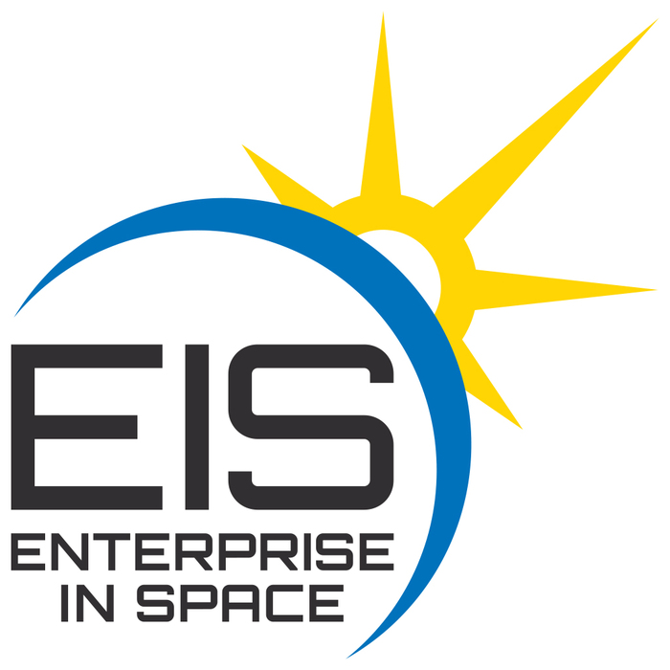
Small Steps Teaching Space Science Brings
Giant Leaps Into Space !

Feb 9, 2017 SEEC Workshop presented by Enterprise In Space

Topics Covered in This Session:
Trek-A-Sat Activity Introduction

Introduction to the EIS Academy

Albedo Experiment and Orbital Debris

Spacecraft, Plasma, and The Aurora

The LEO Art Challenge

Trek-A-Sat Activity Follow-up

EIS Opportunities

Evaluation

