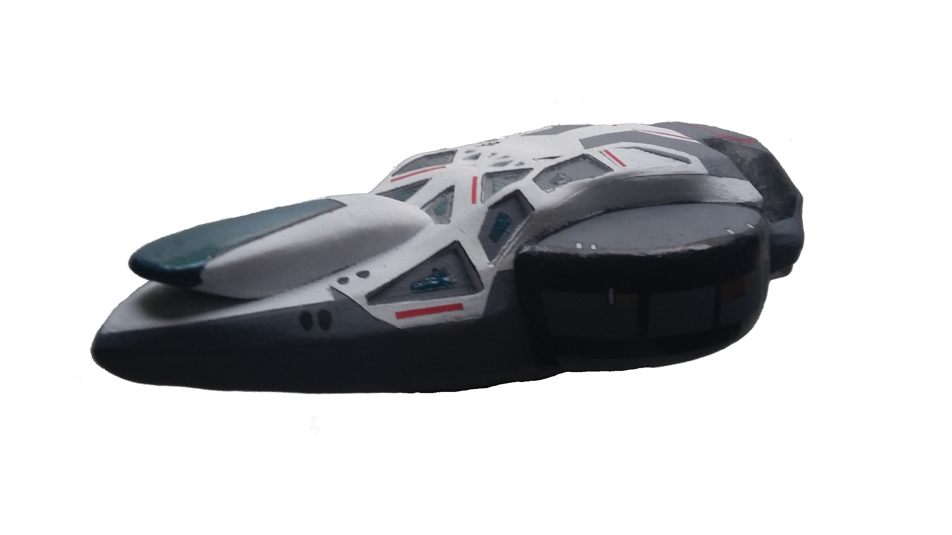
Trek - A - Sat Activity
NSS Enterprise

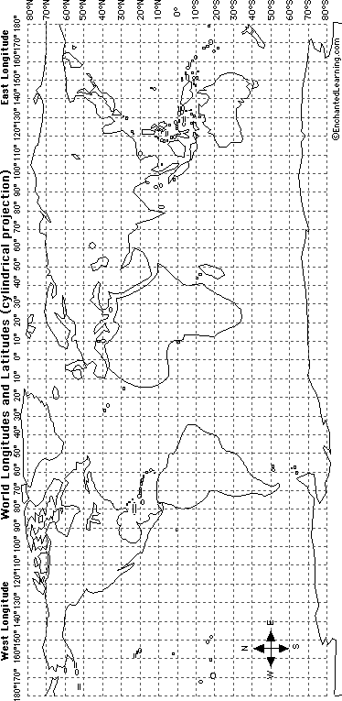

www.enterpriseinspace.org

