10 SPACE JOBS FROM THE NEAR FUTURE
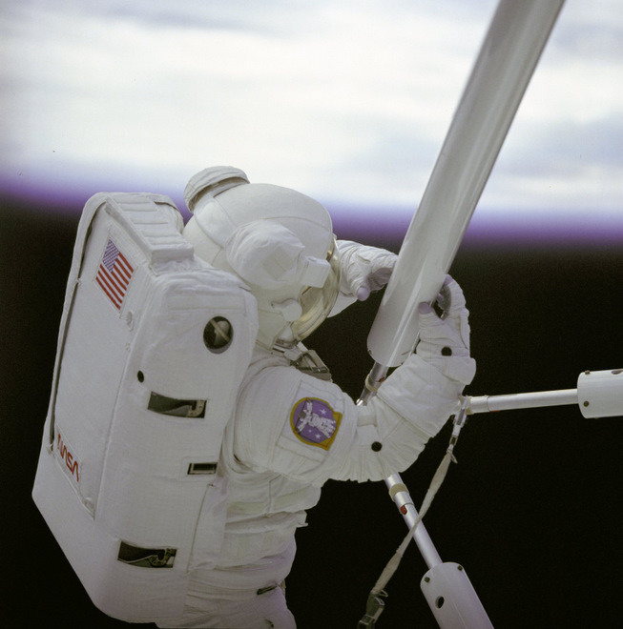
Prototype space construction during STS-61B (image: nasa.gov)

THE UNITED STATES’ government-run manned spaceflight program was given a one-two punch in the last year. In August 2009, the Augustine Commission (appointed by the Obama administration) recommended that NASA look to commercial space operators to take on the burden of ferrying mission commanders, scientists and specialists up to the International Space Station. Then in February 2010, the administration’s 2011 budget reflected that charge.
This article has been reproduced in a new format and may be missing content or contain faulty links. Contactwiredlabs@wired.com to report an issue.
If Congress goes through with the budget proposal (and that is a big if), NASA will stop work on the Constellation program, including the in-development Orion module and Ares rocket and focus instead on a new heavy-lift vehicle and new space-related technologies. The move will pave the way for companies like SpaceX to take up the helm for low-Earth orbit (LEO) human spaceflight.
And, while other fledgling spaceflight companies like Virgin Galactic are not preparing to send people all the way up to the space station, they and other commercial companies are also making waves.
So what will a job market for the aspiring space junkie look like in 20 to 30 years? For a long time, the single goal for kids that were obsessed with spaceflight was to become an astronaut. Now, it looks like that job title will have some competition. Here are 10 non-scientist jobs I believe youngsters should start to prepare for:

LEO PILOT (EVENTUALLY, LUNAR TRANSFER PILOT)
Nerves of steel, excellent piloting skills (atmosphere and LEO). Must be able to calm tourists and provide comedic banter during flight. Virgin Galactic has the lock on this job category for the next few years. But Jeff Bezos is doingsomething out there in the Texan desert.

SPACE-TRAVEL TICKET BROKER
While most travel agents are going the way of the dinosaur, a sub-culture of space-travel ticket brokers are just beginning to spring up. Their specialty will be helping you to plan your next trip to LEO, a space-based hotel stay or the ultimate lunar adventure.

SPACEPORT TRAFFIC CONTROL (ALSO, ON-ORBIT TRAFFIC CONTROL, EARTH AND LUNAR)
The skies can get busy once the industry begins to take off. Currently, the FAA has jurisdiction over private sub-orbital spaceflights. But if a company decides to take their business to the next level and go orbital, a new breed of traffic controller will need to be trained.

HUMAN-RATED SPACECRAFT MAINTENANCE
Many of the country’s rocket builders are working on unmanned vehicles. As we get more human-rated craft ready for launch, specialists in this type of maintenance (life support systems, escape systems, etc.) will become more common.

SPACE COMMUNICATIONS SPECIALIST
Digital communications between space crews and their respective homebases will be a critical factor in any company’s success. And besides, we’ll need someone around to make sure all of the tourists’ Twitter and Facebook updates make their way to the internet from LEO or beyond.

SPACE CONSTRUCTION AND REPAIR SPECIALIST
As more permanent structures are built in LEO, it will take a specially trained person to handle repairs and upgrades. Some of these positions will be in situ (imagine putting in a three-month maintenance rotation), while others will blast up to their construction sites as needed.

LUNAR BASE PSYCHOLOGIST (PRESENCE ON THE MOON NOT REQUIRED)
Living for six months on the ISS is one thing. You are a Soyuz escape pod away from home. But, living on the moon will be a completely different experience. If we have regular flights up to lunar orbit, then you are at least three days away from being back under blue skies. And living in a desolate environment like the Moon could have an adverse psychological impact (studies are underway). Being that far away may give people thoughts of seceding from Earth.

MARS COLONY PSYCHOLOGIST
If you think living on the moon is difficult, try living on Mars for two years, with little to no chance of rescue if things go bad. Add in the 11 minute communication delay and one word sums up your experience: isolated. Our Russian and European friends are already experimenting with extremely long-term disconnectedness (see Mars500). In addition to helping maintain the mental health of any Martian exploration group, a thorough psych exam will be a part of any team-selection process.

NUCLEAR AND SOLAR POWER ENGINEERS
Any base on the moon or Mars will need to generate its own power. Solar is the best bet for the moon (depending on the base location). However, a good nuclear generator would make a good backup. And it will be almost required for any long-term Mars and asteroid-belt mission.

ON-ORBIT REFUELING SPECIALIST
One of the more exciting proposals to come out of the Augustine Commission was the idea of maintaining fuel depots on orbit. The plan is to provide service contracts to commercial spaceflight companies to keep these depots topped off with rocket propellant. With the depots in place, we could maintain a fleet of space-worthy craft that would serve as shuttles to lunar space or out to Mars and beyond. A space-based gas station!

.
And lots more to think about…….

