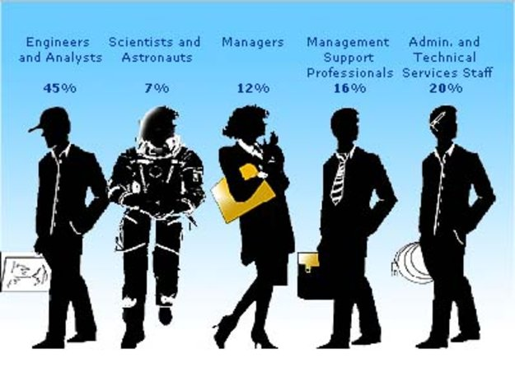
Careers in Space:

Annotated Bibliography of Recommended Reading
2008: Tourists in Space: A Practical Guide, By Erik Seedhouse. Springer-Praxis. 314 pages. [Review]. [Amazon link]. The bulk of this book goes into considerable detail about what sort of training prospective spaceflight participants should undergo.
2007: Rocketeers: How a Visionary Band of Business Leaders, Engineers, and Pilots Is Boldly Privatizing Space, by Michael Belfiore. Smithsonian Books. 304 pages. [Review]. [Amazon link]. An excellent and exciting read that allows you to meet the major players in the development of privatized space flight.
2007: Destination Space: How Space Tourism Is Making Science Fiction a Reality, by Kenny Kemp. Virgin Books. 262 pages. [Amazon link]. A more accurate title would be The Virgin Galactic Story because that is essentially all that is covered (note that the publisher is Virgin Books).
2005: The Space Tourist's Handbook, by Eric Anderson and Joshua Piven. Quirk Books. 192 pages. [Review]. [Amazon link]. A more accurate title would be The Space Adventures Story because author Eric Anderson is president of that company — the first company to actually fly space tourists.
2004: Space Tourism: Do You Want to Go? by John Spencer. Apogee Books. 224 pages. [Amazon link]. A broad overview of the entire topic of space tourism, written by the founder and president of the Space Tourism Society. Offers unique perspectives not found elsewhere, such as parallels with the yachting and cruise industries. A significant contribution to the literature.
2002: Making Space Happen: Private Space Ventures and the Visionaries Behind Them, by Paula Berinstein. Plexus Publishing. 490 pages. [Amazon link]. A broad overview of space privatization featuring extensive interviews with the movers and shakers that are making it happen.
1998: General Public Space Travel and Tourism: Volume 1, Executive Summary. Joint NASA study concludes that serious national attention should be given to enabling the creation of in-space travel and tourism businesses, and that, in time, this should become a very important part of our country's overall commercial and civil space business-program structure. 40 pages. [PDF 100K]
1996: Halfway to Anywhere: Achieving America's Destiny in Space, by G. Harry Stine. M. Evans and Company. 306 pages. [Review]. [Amazon link]. Discusses what is involved in airline-like operations for spacecraft, and provides a history of the first re-usable rocket, the Delta Clipper.

LINKS & RESOURCES
Rocketplane Global
Scaled Composites
Space Access Society
Space Adventures
Virgin Galactic
XCOR Aerospace
X-Prize Foundation
Zero-G Corporation
Wall Street Journal: Economy Fare ($100,000) Lifts Space-Tourism Race
Climbing a Commercial Stairway to Space: A Plausible Timeline?
Anousheh Ansari - First Female Private Space Explorer
Space Future - Space Tourism
Wikipedia - Space Tourism
Space Tourism Society
Space.com: All About Space Tourism
Space Tourism - Multimedia Special Report (13 minutes)
NSS News Archive on Space Tourism

This information is from The National Space Society http://www.nss.org

