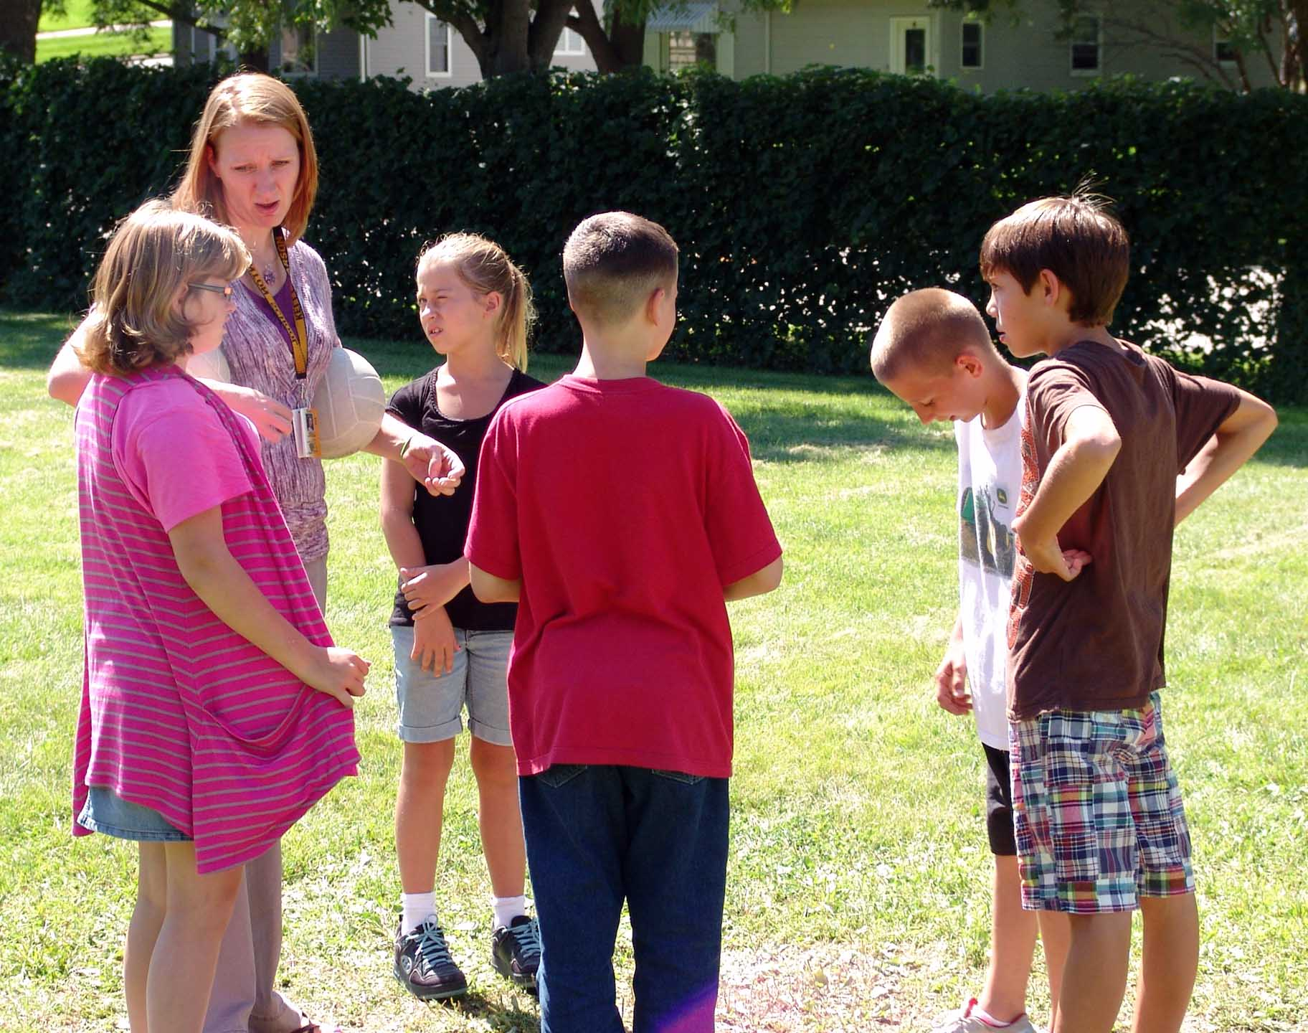
Teacher Tips for Solar System Models
Here are some points that might help your lab be successful:
- Have students complete all calculations for determining the scale of their solar system using the given ball and make their 'planet flags' on one day, then lay out their particular solar systems on another day.

- Students will be more engaged if the weather is warm, low winds, and rain has not been experienced in 24 hours.
- Find a very large area to have students lay out their individual solar systems.

- Use different colored flags for each group's planets so that you can pick them out at a distance.

- Show students how to use the tape measures so that tangled tapes are avoided.

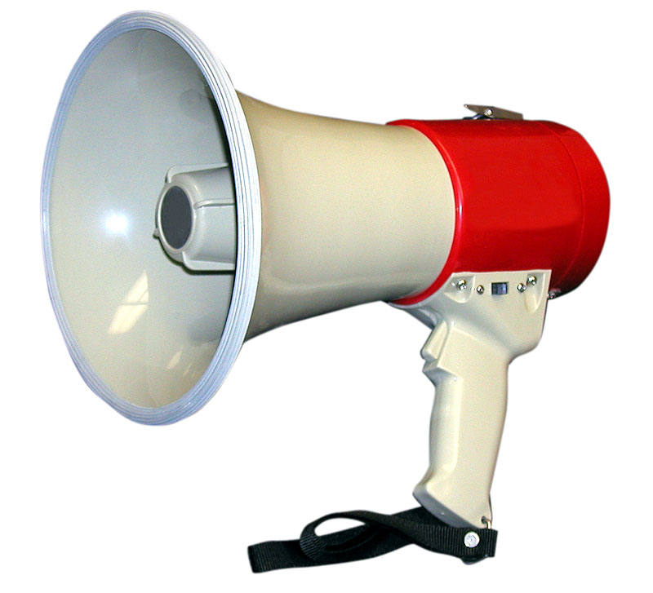
- Have each student 'elect' a captain within their group for final decision making and for communication to the teacher.

- If you have radios, use them for students that have chosen a larger ball for the sun because they will be farther from you. A whistle or a fog horn would be very advantageous for the teacher.
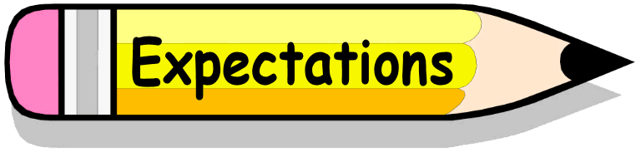
- Explain expectations for the lab:

- Tell students how much time they will have to lay out their solar system model before they will be called to leave their models and return to the Base Area for model comparisons.
- Designate the Base Area where the sun models will be placed and measurements for the planet locations will be begun.
- Students lay out their planets in as straight a line as possible so they do not stray into another group's solar system line.
- Each group shows respect for other groups so that activities do not adversely affect any other group's efforts.
- Set up the guidelines for the area designated for student solar systems.
- Tell students they will be called in to return to the area of the model suns at your signal. They will leave their flags and tape where they stop.
- Students retract tape measures and bring all materials
back to the Base after model comparisons are made and when signaled to do so.

- When students return to the Model Sun Base Area, the captain of each group shares the group's scaling factor and the color of the flags with the other groups. Compare smaller to larger scaling factors or smaller to larger scaling factor helps student organize the information.
- Give students about 5 - 8 minutes to quickly gather their supplies and return to the Base Area with all items.

