WHAT CAUSES THE AUROA?
A Kinestatic Activity
Teacher Notes

Objectives:

Students will be able to:
- Act out the scientific phenomena that cause aurora
- Explain two factors that cause aurorae to be different colors

Description:

In this kinesthetic activity, students will learn how particles in Earth’s magnetic field cause aurora. The Sun’s eruptions and solar wind interact with Earth’s magnetic field, much like in a generator, powering electric currents in Earth’s magnetic field. These electric currents are carried primarily by moving electrons, which spiral along Earth’s magnetic field. When these particles interact with atoms and molecules in Earth’s ionosphere, energy is transferred and electrons jump orbital levels. After time, the electrons transition back to their normal state producing light that we see as the aurora. A full tutorial and explanation can be found at Dawn of the North (http://sprg.ssl.berkeley.edu/aurora_rocket/aurora/welcome.html). An analogy between how a Cathode Ray Tube (CRT) works and how aurora are created can be found at Television in the Sky (http://sprg.ssl.berkeley.edu/aurora_rocket/education/crt/index.htm).

Before this activity, students should have viewed footage of solar eruptions and images of different colored aurora. In this activity, students will act out how charged particles and ions that come from these eruptions and the solar wind can excite oxygen and nitrogen atoms in Earth’s ionosphere and create aurorae.

How to Prepare:

If you are going to pass out copies of the diagrams, leave time to make copies prior to the activity. An alternative would be to project the images on a screen. Review the Vocabulary section below prior to the activity (you can find helpful definitions on the NASA Cosmocopia website, which is listed in the Resources section). Your students should have some familiarity with the vocabulary mentioned below and basic concepts relating to how space weather affects Earth. Lessons that can be used to build prior knowledge of these concepts can be found on the NASA Sun-Earth Day and University of California, Berkeley’s Center for Science Education website; the NASA Mapping Magnetic Fields lesson may also be helpful. See the Resources section below for links to these lessons.

Background Information:

Solar observing spacecraft like the Solar and Heliospheric Observatory (SOHO) and Solar Dynamics Observatory (SDO) study how solar activity is created, how it affects space weather, and how it influences life on Earth including humanity's technological systems. These types of spacecraft take footage of solar events, including solar eruptions (also called Coronal Mass Ejections or CMEs) and solar flares.

Aurorae are powered by solar eruptions and the solar wind, both of which release plasma into space that contain charged particles: ionized atoms and electrons. The interaction of these solar charged particles with Earth’s magnetic field powers electric currents around Earth. These electric currents are carried primarily by moving electrons within a magnetic shell known as Earth’s Magnetosphere and into Earth’s upper atmosphere. Thus, the electrons that ‘turn on’ the auroral lights in the night sky at high latitudes come from this magnetic space around Earth – Earth’s magnetosphere.

As these magnetospheric electrons are energized by the solar wind and solar eruptions, some electrons move along Earth’s magnetic field. The electrons within the magnetosphere that follow Earth’s magnetic field into Earth’s upper atmosphere, are those responsible for causing Earth’s upper atmosphere to glow – this glow is commonly called aurora. As the electrons hit the oxygen atoms and nitrogen molecules in Earth’s ionosphere (where the Earth’s atmosphere meets space), the atoms become excited and subsequently release the energy as light that cause the air to glow. When solar eruptions interact with Earth’s magnetosphere above and beyond the ‘calm’ solar wind, this extra energy can cause the lights of the aurora to dance across the sky and sometimes make it to the southern states of the U.S., such as Florida, Texas, and Southern California. To learn more about these topics in more detail, we recommend the NASA THEMIS guide: http://nasawavelength.org/resource/nw-000-000-002-714/

Aurora can be many different colors, which is due to several factors. In the activity, two of these mechanisms are touched on. If charged particles and ions interact with different types of atoms or molecules in the ionosphere (i.e. oxygen atoms or nitrogen molecules), a different color light can be released. Another factor is the level to which an atom or molecule is excited. It is possible that if the same type of atom or molecule, like an oxygen atom for instance, is excited at different levels, it can release different colors of light at these different levels of excitement.

Vocabulary:

- atom - electrons - magnetosphere
- aurora - ion - molecules - solar wind
- coronal mass ejection (CME) - ionosphere - solar eruption
- Earth’s atmosphere - magnetosphere - solar wind
- space weather

Directions:

- Tell students that you will be discussing how aurorae are caused. Ask them if they know what aurorae are. (Many students have heard of the Northern and/or Southern Lights so you may want to explain that they are synonymous.) Show images of different colored aurora to give them a visual of what they are. (You can find images on the SpaceWeather.com link found under Resources.) Note: The different colors of aurora will be referred to during the lesson so it would be helpful to show them pictures displaying various colors.

- Ask students what they think causes aurorae. After taking some ideas, discuss that aurorae are powered by motion of particles coming from the Sun. Review generator mechanisms, electrical currents, and what students learned about solar activity, specifically about how the Sun releases charged particles and ions via coronal mass ejections (CMEs) and the solar wind.

- Show the diagrams that appear at the end of this activity and go over the vocabulary listed on it (i.e. the ionosphere is where Earth’s atmosphere meets space, Earth’s magnetosphere is the magnetic field of the Earth). You can refer to the diagram(s) as you walk through the kinesthetic activity that follows. Project this image on a screen in front of the class if you can or print out the image to give out to students.

- Tell students that they are going to act out how aurorae are caused. Have students stand up. Tell them to imagine that from the waist down, their body represents the Earth; from their waist up, their body represents the Earth’s atmosphere; and their head represents an oxygen atom in the Earth’s ionosphere. You can refer to the diagram as you are pointing out to students what the parts of their bodies are representing.

- Tell students to raise their arms straight up into the air—their arms represent magnetic field lines that make up the Earth’s magnetosphere (you can refer to the diagram to point out where they are located). Their arms would be pointing straight up if they were in an extremely northern (i.e. Alaska, Greenland or northern Canada) or southern region (i.e. Antarctica). The magnetic field lines are more vertical at the poles than at other places on Earth in these regions.

- Optional: Have students angle their arms at the inclination you found for the location where you are located. You can find this angle by looking at the magnetic field image in this presentation: http://nasawavelength.org/resource/nw-000-000-002-063/. Ask the students why their arms would be tilted in this way at lower latitudes, such as California, Kansas, or Georgia. (Answer is because Earth’s magnetic field is mostly a dipole magnetic field, meaning that at the magnetic poles the magnetic field points straight into space and as one moves to lower latitudes, the magnetic field becomes more and more vertical.)

- Tell students that they are pretending to be in northern Canada. Ask them to move their arms to the direction they think they should be pointing (their arms should be pointing straight up).

- Tell students to imagine that a CME blasted off the Sun a few days ago, causing charged particles (electrons and ions) to blast through space and head toward Earth. Keeping their arms extended overhead, have students turn their wrists around in circles. Tell them that this represents the energized magnetospheric electrons that carry the electric current powered by the CME. These electrons spiral around the magnetic field lines of Earth’s magnetosphere.

- While they keep turning their wrists in circles, have them spiral their arms down and tap themselves on the head. Repeat this a few times. This represents electrons hitting an oxygen atom their head) in the ionosphere.

- Have students shake their heads around. While they do this, they should put their arms down at their sides and stop moving their wrists. Their head shaking represents an oxygen atom getting excited after being hit by electrons.

- Have all the students let out a big sigh and then stop shaking their heads. Ask them what the sigh represents—if they need help, remind them that their head (the oxygen atom/nitrogen molecule) stopped moving after they sighed.

- After taking their answers, make the point that the sigh represents the excited oxygen atom releasing energy, which it does in the form of light. This is what causes aurorae; the air glows from this release of light energy from excited atoms in the ionosphere.

- Repeat Steps 7-12 at least once to reinforce concepts. During this time, have students imagine their head is a nitrogen molecule instead of an oxygen atom. Use this opportunity to teach them that different types of elements in the ionosphere glow because of their interaction with these electric currents in Earth’s magnetosphere, which are energized from the Sun’s interaction with Earth’s magnetosphere.

- To assess student understanding, have them go through the steps themselves without you leading. You can have volunteers come up and walk through the steps, explaining what is happening and leading the class through them. You can also have students write out the steps after the activity using the diagram and vocabulary words as a reference.

Extension Activity: What causes auroras to be different colors (this should follow steps 1-15 above)-

- Refer back to the images of the aurorae you showed in Step 1. Point out that aurorae can be many different colors and you will discuss two of the reasons. Explain that they already acted out one of them when they imagined their head was an oxygen atom and then a nitrogen molecule. If charged particles hit different types of atoms or molecules in the ionosphere, this can cause different colored light to be released.

- Tell students they will now act out a second factor that causes aurorae to be different colors.
  - Have them repeat Steps 7-11 with their head as an oxygen atom shaking very fast—as fast as they can. They should release a big sigh (this represents a large amount of energy being released by the very excited atom). Tell them that they just caused a green aurora.
  - Have them repeat Steps 7-11 with their head still as an oxygen atom, but this time shaking more slowly. They should release a small sigh (this represents a small amount of energy being released by the less excited atom). Tell them that they just caused a red aurora.

- Ask students to summarize two factors that cause aurorae to be different colors.

Connections to other NASA missions:

- Connections can be made to NASA’s THEMIS mission, which is investigating what causes aurorae to dramatically change shape and color. You can find related lesson plans and other useful information on the THEMIS mission education website (see link under Resources below).
- Aurorae happen on worlds other than Earth! NASA spacecraft have observed aurorae on other planets and even moons. For instance, the Hubble Space Telescope has captured images of aurorae on Jupiter and Saturn, while the Galileo spacecraft observed them on Jupiter’s fifth moon, Io. You can find more information and links to images on the University of Alaska-Fairbanks website (see link below).

Resources:

- Dawn of the North: A Tutorial on Auroral Creation http://sprg.ssl.berkeley.edu/aurora_rocket/aurora/welcome.html
- NASA—Aurora brochure (printable):
http://nasawavelength.org/resource/nw-000-000-002-773/
- NASA—Cosmocopia glossary: http://helios.gsfc.nasa.gov/glossary.html
- NASA—Mapping Magnetic Fields lesson:
http://nasawavelength.org/resource/nw-000-000-001-855/
- NASA Sun-Earth Day—Space Weather Action Center: http://sunearthday.nasa.gov/swac
- NASA THEMIS—Education and outreach website: http://cse.ssl.berkeley.edu/artemis/epo.html
- SpaceWeather.com—Aurora Gallery: http://spaceweather.com/aurora/gallery.html
- Univ. of Alaska-Fairbanks—Aurora FAQ: http://odin.gi.alaska.edu/FAQ/
- Univ. of California, Berkeley’s Center for Science Education: http://cse.ssl.berkeley.edu/magnetism
- Sun-Earth Connection presentation: Univ. of California at Berkeley http://nasawavelength.org/resource/nw-000-000-002-063/
- Television in the Sky: An Aurora and Cathode Ray Tube Analogy http://sprg.ssl.berkeley.edu/aurora_rocket/education/crt/index.htm.

What Causes Aurora Diagram

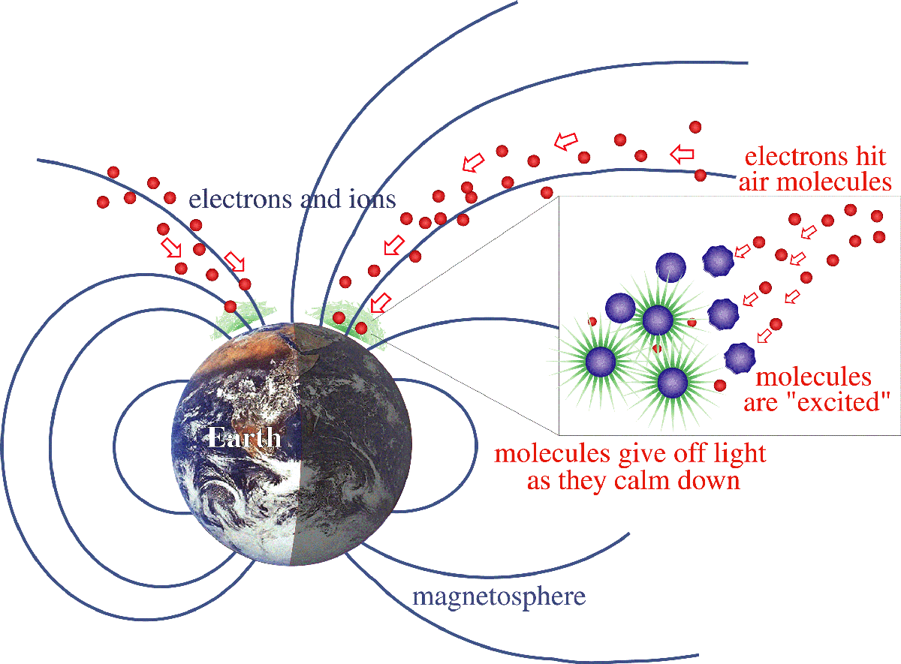

Let’s Make An Aurora



YOUR ROTATING HANDS
Represent electrons (particles) from space

YOUR SIGH
Represents aurora light
YOUR ARMS
Represents Earth’s magnetic field lines in the polar region
YOUR HEAD
Represents a Nitrogen or Oxygen atom in the upper atmosphere
YOUR UPPER BODY
Represents Earth’s upper atmosphere (60 miles/100 km) above Earth’s surface
AURORA
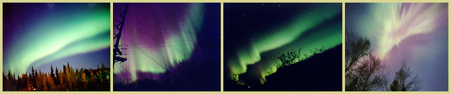

YOUR LOWER BODY
Represents Earth

An aurora is caused by electrons from space spiraling down Earth’s magnetic field lines into the upper atmosphere and exciting atoms in the atmosphere like Oxygen (red and green) and Nitrogen (blue and red).

