Questions to follow NASA Clip on Scale Modeling: Name_______________________________ Period _________
(Be sure and pause the video so that you have a chance to think about your answers!) [ https://www.youtube.com/watch?v=Cv7_CVD6_Yk ]
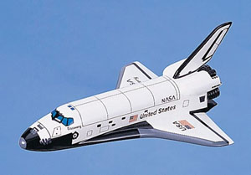
- What does it mean to scale an object?

- Why is it important to use scale models or drawings?

- List some math terms that are mentioned in the video and used with scale models or drawings.

- Show your work for finding out the height and distance from wing to wing of the space shuttle.

