Resources Used and Referenced in BTCI Session

Videos:
- Moon and More Video: 3 min 40 sec
https://www.youtube.com/watch?v=PPB1ZHb9FKA

- Hidden Figures to Modern Figures Video: 2 min 10 sec
https://www.youtube.com/watch?v=L0aMYm-9TBU
- Toys in Space: Videos are sited on the Toys In Space Lab

- Imagine Mars - video: 5 min
https://mars.nasa.gov/imagine/students/


Websites:
- Yerkes Observatory, Williams Bay, WI
http://astro.uchicago.edu/yerkes/
- SEEC (Space Exploration Educators Conference)
Johnson Space Center, Houston, TX
https://spacecenter.org/teacher-programs/teachers-seec/
- NSTA
https://www.nsta.org/
- Enterprise In Space (EIS) www/enterpriseinspace.org

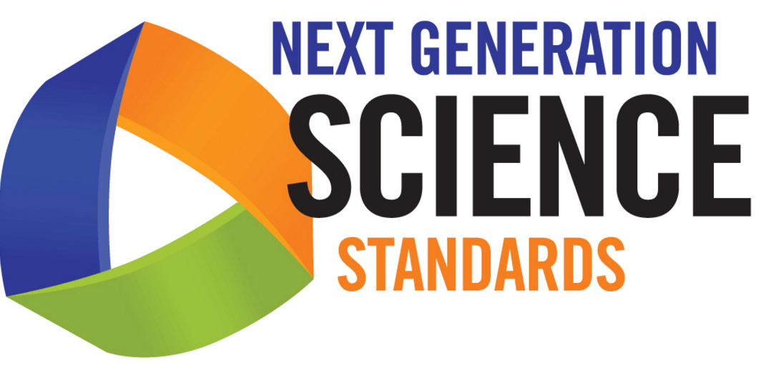
- Toys In Space:
Space Systems: MS-ESS1-2; Engineering Design: MS-ETS1-2
- Plasma Globe Experiments:
Chemical Reaction: MS-PS1-2,6
Structure and Properties of Matter: MS-PS1-4
Human Impacts: MS-ESS3-2
- Imagine Mars:
Space Systems: MS-ESS1-2,3 Engineering Design: MS-ETS1-1
- All Activities:
Science and Engineering Practices:
Analyzing and Interpreting Data
Engaging in Argument from Evidence
Developing and Using Models

