Spectral Analysis Activity

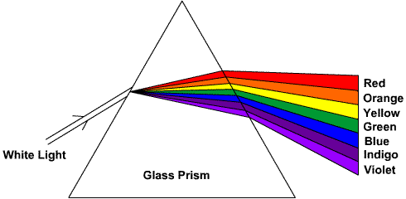
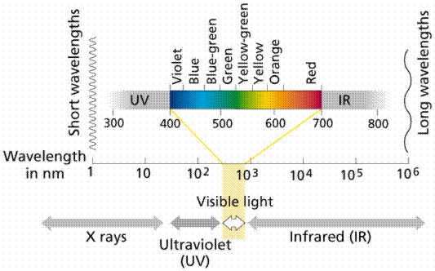
Our modern understanding of light began when Newton passed a beam of white light through a prism and found that the light was broken up into the colors of the rainbow. This rainbow of colors ranges from violet at 400nm to red at 700nm and is called the visible spectrum.
Scientists designed and constructed instruments to help them examine the spectra.
What do we call the range of colors to the right?

An instrument used to observe spectra visually is called a SPECTROSCOPE. This instrument produces a photograph of the spectrum called a SPECTROGRAPH. Scientists use spectroscopes to determine:
- The element the star is made of
- The star’s movement relative to earth
- The temperature of the star
- How fast the star is spinning
Purpose
- To learn that light is broken up into many types that we use to gather information about objects in the universe
- To explain what information we can learn about objects in the universe from the light data telescopes collect

Materials
Scissors
Stapler

Procedure
- Cut out the “Pull Tab Out” card along dashed lines.
- Cut out the “spectroscope fingerprints” card along dashed lines.
- Cut out Star B, Star C, Star C₁, Star C₂, and Star C₃ along dashed lines.
- Make 5 cuts along the dashed lines A, B, C, D, E on the “spectroscope fingerprints”, making sure to stop at the dots at the ends of the dashed lines.
- From right to left, weave “pull tab out” down slit A and back up slit B, down through slit C and back up slit D, then down through slit E.
- Always keep the “reference lines” aligned. Each element has this reference line for purposes of alignment.
- Match spectral lines of the known elements with the unknown sample spectrogram (Star A).
- Star B, C, C₁, C₂, and C₃ are provided for further study and comparison. These spectrograms can be stapled on top of Star A and the “spectroscope “fingerprints” card.
Name: ______________________________________ Date: _________________ Period: ________ Table #_________

Spectral Analysis Activity

Data table for the stars

Below mark the elements that are found in each star using the spectral analyzer you made. Put check marks in the boxes representing the elements in each star.

 | Iron | Calcium | Sodium | Hydrogen | Helium | Argon | Mercury | Neon
A
B
C

Questions

Sometimes scientists see spectral lines that do not fit the usual pattern. The lines might be shifted from their usual positions which may suggest the star is moving either toward the observer (BLUE SHIFT) or moving away from the observer (RED SHIFT).

- Look at the spectral lines for star C and star C₁. Star C is not moving relative to us.
  - Explain how the spectrum of star C₁ is different from the spectrum of star C?

  - What can you tell about the movement of star C₁ from its spectrum?

- Now compare the spectral lines for Stars C and C₂. Star C is not moving relative to us.
  - Explain how the spectrum of star C₂ is different from the spectrum of star C?

  - What can you tell about the movement of star C₂ from its spectrum?

- Now compare the spectral lines for Stars C, C₁, and C₃. Star C is the standard for comparison and both Stars C₁ and C₃ are red shifted.
  - How is Star C₃ different from Star C₁?

  - What is the possible explanation for the difference between Stars C₁ and C₃?

